RI.8 (Hearing the Argument)

Delineate and evaluate the argument and specific claims in a text, including the validity of the reasoning as well as the relevance and sufficiency of the evidence.

|  |  |
| --- | --- |
| RI.2.8 | Describe how reasons support specific points the author makes in a text. |
| **RI.3.8** | **Describe the logical connection between particular sentences and paragraphs in a text (e.g., comparison, cause/effect, first/second/third in a sequence).** |
| RI.4.8 | Explain how an author uses reasons and evidence to support particular points in a text. |

Supporting Skills and Strategies

* Define *sentence*
* Define *paragraph*
* Recognize text structures

G: I can describe the connection between sentences in a paragraph

A: Watch the video clip “One of These Things” <http://www.youtube.com/watch?v=6b0ftfKFEJg>

N: Define sentence and paragraph.

A sentence is a group of words that tells a complete thought.

A paragraph is a collection of sentences that are logically ordered and all related to one main topic.

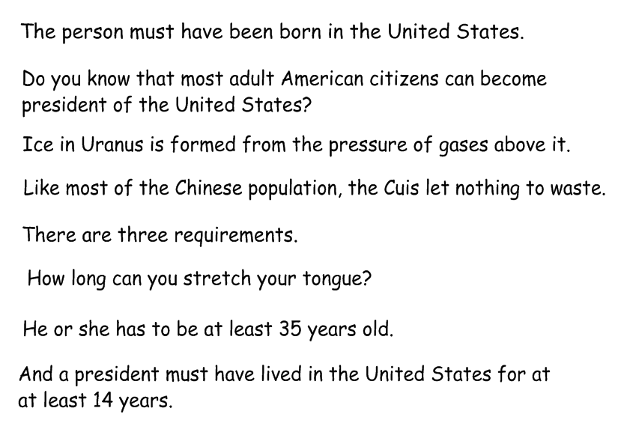

How many sentences are on the slide?

Find the sentences that are related.

Explain why you chose them.

Put them in a logical order.

Check using page 7 of

The Presidency by C. Taylor-Butler

A: Practice determining which sentences are related and go together to make a paragraph.

Pg. 11

Pg. 17

G: Revisit the goal- score understanding and effort

G: I can describe the connection between paragraphs in a text.

A: “What do you notice about the pictures?

N: Review the definition of a paragraph.

A paragraph is a collection of sentences that are logically ordered and all related to one main topic.

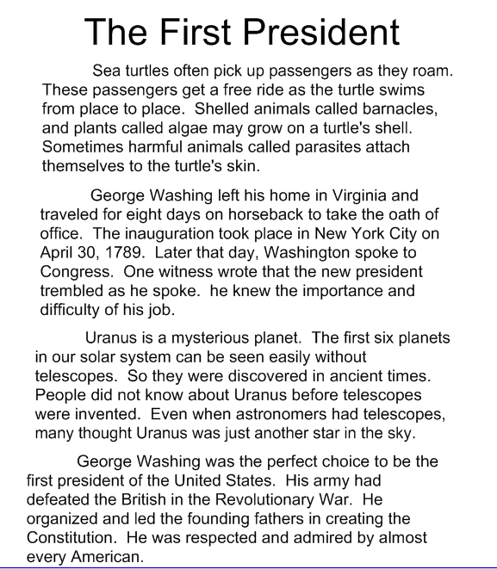

How many paragraphs are on the slide?

Find the paragraphs that are related to the presidency.

Explain why you chose them.

Put them in a logical order.

Check using page 20-21

The Presidency by C. Taylor-Butler

A: Practice determining which paragraphs are related and go together.

Pg. 22-23 (explains his decisions- does not depend on sequence)

Pg. 27-29 (sequential)

G: Revisit the goal- score understanding and effort