One Day Research

The following writing prompt could be used with any of the inventor biographies from Unit 3. If possible, consider having students take quick notes on a piece of paper and then compose their essay at a computer to allow for practice composing digitally.

This assignment could be used to assess the following standards:

* RI.3.3 Describe the relationship between a series of historical events, scientific ideas or concepts, or steps in technical procedures in a text, using language that pertains to time, sequence, and cause/effect.
* RI.3.10 By the end of the year, read and comprehend informational texts, including history/social studies, science, and technical texts, at the high end of the grades 2-3 text complexity band independently and proficiently.
* W.3.6 With guidance and support from adults, use technology to produce and publish writing (using keyboarding skills) as well as to interact and collaborate with others
* W.3.7 Conduct short research projects that build knowledge about a topic

Essay Question:

*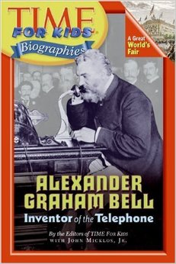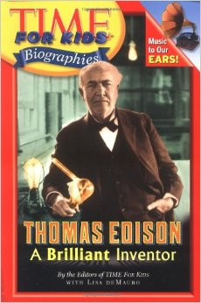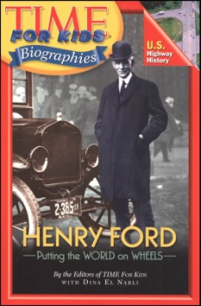What contribution did _______________ make to history? What events or problems led to their invention(s)? Use evidence from the text to support your answer.*

9 copies each