**Rainbow Loom: A hot new toy as much for boys**

**as girls**

By **Chicago Tribune, adapted by Newsela staff**

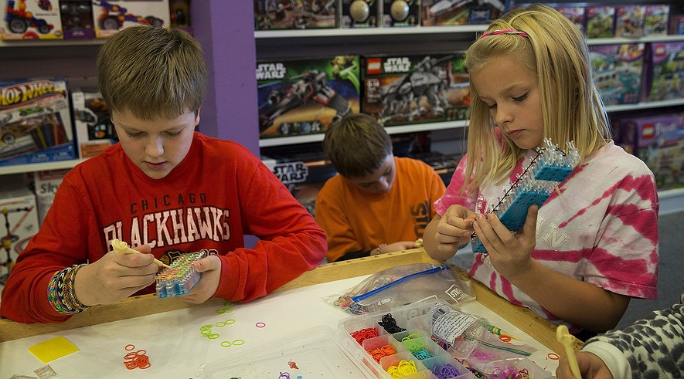**Nov. 12, 2013**  midnight

(From left) Conor Flanagan, 11, Garrett Fill, 10, and Sydney Parquette, 9, work on their looms during a Rainbow Loom class at Learning Express Toys in Geneva, Ill., on Oct. 26, 2013. Photo: Andrew A. Nelles/Chicago Tribune/MCT

CHICAGO — Angelo Notarangeli loves to skateboard and play basketball. He isn't much into arts and crafts. But when it comes to the Rainbow Loom, that's a different story.

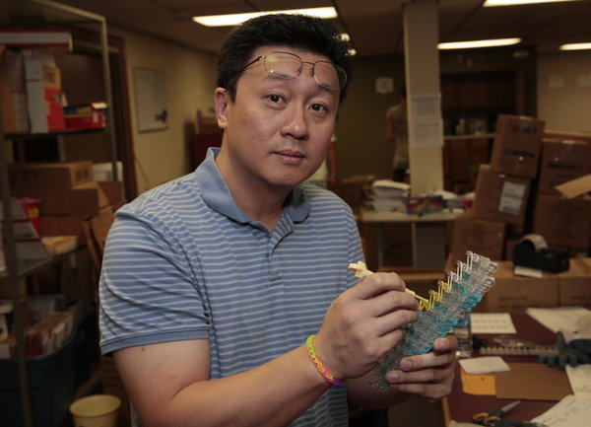“There are like 10 people at school that don’t have them. Everyone else is into it,” said Angelo. The 8-year-old boy lives in Illinois.

Many kids go crazy over a really popular toy. Toy store owners and parents are surprised that boys love the Rainbow Loom as much as girls do.

The Rainbow Loom is a toy that helps kids weave colorful rubber band bracelets. It was invented by Cheong-Choon Ng. Ng is a car safety engineer from Michigan. His two daughters enjoyed making rubber band bracelets. But Ng couldn't join in. His fingers were too big to make the tiny knots. So he created a toy loom that made weaving the bracelets easier.

Cheong- Choon Ng

## http://media.cleveland.com/plain-dealer/photo/2013/10/13644153-standard.jpegAlmost Everyone Wants One

Each kit contains a small loom. It includes mini rubber bands to make 24 bracelets. It also includes a hook to weave the rubber bands into stretchy, brightly colored jewelry. The kits cost $15 to $17 each. So far, Ng has sold about 3 million kits.

At Learning Express Toys in Naperville, Ill., the checkout counter is surrounded by loom kits and sample bracelets. A screen runs Rainbow Loom lessons on repeat. There are buckets of shiny Rainbow Loom charms and colorful rubber bands. It is an eye-catching display of tie-dye, glitter and glow-in-the-dark rings.

The looms are in big demand. And they sell out quickly.

But buying a Rainbow Loom can be tough. Many larger stores don’t carry them. At first, most stores refused to sell them. Some Learning Express Toys stores began carrying Rainbow Looms last year. A national crafts store has sold them since August.

When Angelo first heard about the Rainbow Loom, he thought it sounded “really stupid.” But then he kept seeing the bracelets on his friends’ wrists. Some of them looked really cool, he said.

Then Angelo begged his mother, Toni Notarangeli, to buy him a Rainbow Loom. She thought she wasn't hearing him correctly.

## Necklaces In Team Colors

Seve Zdunek owns Learning Express Toys in Geneva. He told Angelo's mom that boys come in all the time. Parents buy nearly half of the Rainbow Looms for boys.

Parents see it as a girl thing, said John Flanagan. He owns Learning Express Toys. But kids just ignore that, he said. His own son Conor, who is 11, likes to wear an armful of bracelets. At his soccer games, almost every player wears a Rainbow Loom necklace in the team colors.

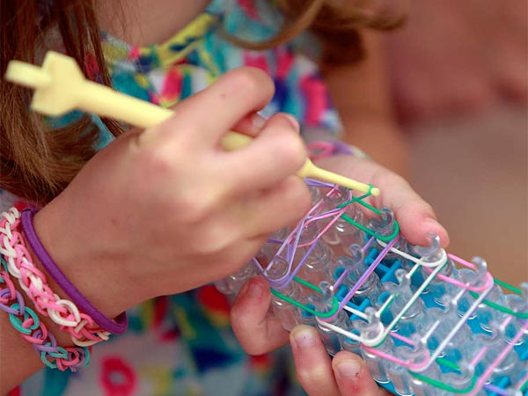Most parents weren’t sure why Rainbow Loom is such a hit with their kids. But they said they hope the fad sticks around. Kids use their imagination. It’s also screen-free, except for the YouTube videos kids watch to learn how to make them. Others said their kids have become generous. They make bracelets for friends and younger brothers and sisters.

McHenry thinks he knows the secret to Rainbow Loom’s success. It is very social.

“Kids have a lot of fun trading bracelets with friends,” McHenry said.

## "You Can Be Really Creative"

Diana Fill loves the Rainbow Loom. It kept her kids busy when her family went on vacation. When they got to the hotel, her son Garrett and his friends pulled out their looms. They then carefully began making bracelets.

“When he told me about it, I said, ‘Honey, isn’t that a girls’ thing?’” Fill said. “But it was nice for us because they were so quiet.”

At a Rainbow Loom class, Garrett, who is 10, worked on a new bracelet pattern. He took the class with two friends.

One of his friends, who is a girl, is surprised that boys like the Rainbow Loom too. Garrett doesn’t see it that way at all.

“I like that you can be really creative and make your own designs,” Garrett said. He likes making bracelets with his favorite sports teams’ colors.

Garrett finished an orange, white, lime green and blue bracelet. He held out his wrist and proudly checked out his work. “They make me look swag."

In this article, the writer describes why the Rainbow Loom is popular with both boys and girls.

Write an original story about a boy or a girl who wants a Rainbow Loom. Make sure to use information from the article in your story.

________________________________________________________________________________________________________________________________________________________________________________________________________________________________________________________________________________________________________________________________________________________________________________________________________________________________________________________________________________________________________________________________________________________________________________________________________________________________________________________________________________

_____________________________________________________________________________________________________________________________________________________________________________________________________________________________________________________________________________________________________________________________________________________________________________________________________________________________________________________________________________________________________________________________________________________________________________________________________________________________________________________________________________________________________________________________________________________________________________________________________________________________________________________________________________________________