**Kids go crazy over the Rainbow Loom**

By **Chicago Tribune, adapted by Newsela staff**

**Nov. 12, 2013**  midnight

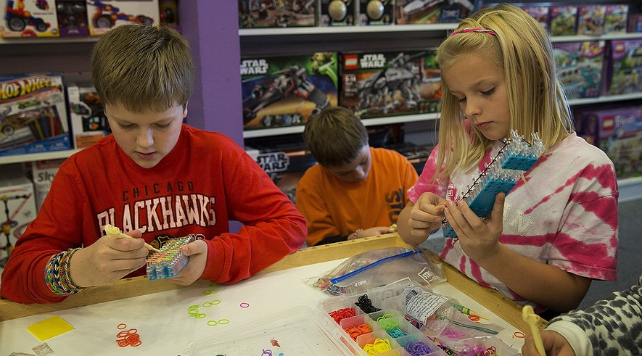

(From left) Conor Flanagan, 11, Garrett Fill, 10, and Sydney Parquette, 9, work on their looms during a Rainbow Loom class at Learning Express Toys in Geneva, Ill., on Oct. 26, 2013. Photo: Andrew A. Nelles/Chicago Tribune/MCT

CHICAGO — Angelo Notarangeli loves to play basketball. He isn't into arts and crafts. But when it comes to the Rainbow Loom, he's a big fan.

“There are like 10 people at school that don’t have them. Everyone else is into it,” said Angelo. The 8-year-old boy lives in Illinois.

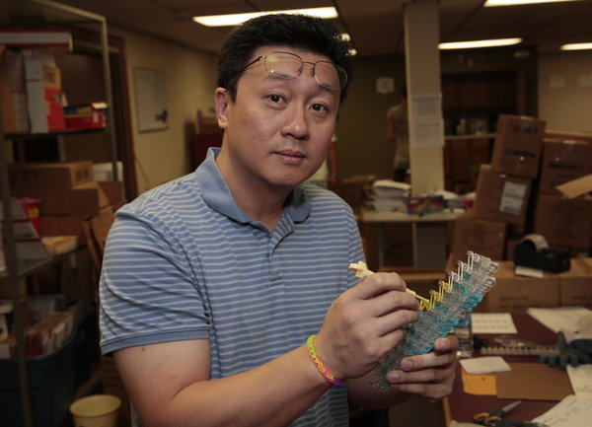Many kids go crazy over a really popular toy. But people are surprised that boys love the Rainbow Loom as much as girls do.

The Rainbow Loom helps kids make colorful rubber band bracelets. It was invented by a man named Cheong-Choon Ng. He is from Michigan. His two daughters liked making rubber band bracelets. But Ng couldn't join in. His fingers were too big to make the tiny knots. But he still wanted to do something with his daughters. So he invented the Rainbow Loom.

Cheong-Choon Ng

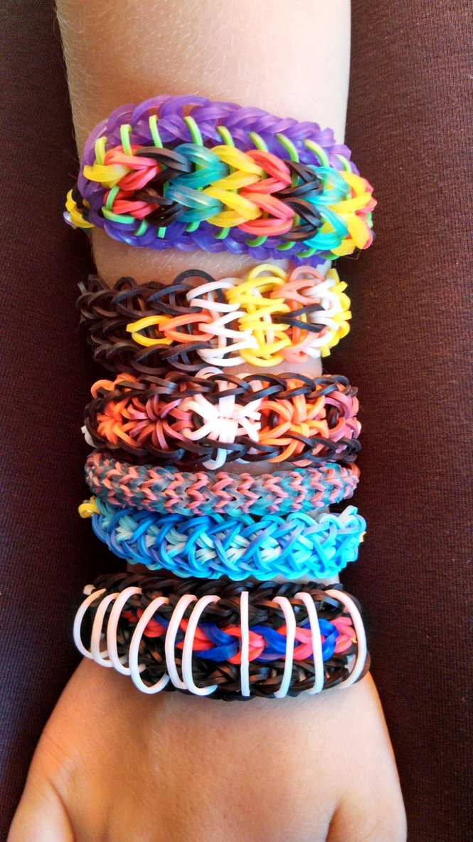**Cool Colorful Wrist Bands**

His older daughter told him he should sell the loom to other kids. His niece came up with the name. His family put together the first kits. Ng sold the first kits in 2011.

In just two years, the looms have become wildly popular. They sell out quickly. So far, Ng has sold about 3 million kits.

But buying a Rainbow Loom can be tough. Many larger stores don’t carry them. At first, most stores refused to sell them.

At first, Angelo thought the Rainbow Loom sounded “really stupid.” But then his friends began wearing the stretchy bracelets. Some of them looked really cool, he said.

Angelo begged his mother to buy him a Rainbow Loom. She thought she wasn't hearing him right.

Parents see it as a girl thing. But kids don't care about that. A toy store owner said boys ask for the Rainbow Loom all the time.

**Thinking Up Patterns**

Most parents don't know why the Rainbow Loom is such a hit. But they hope the fad sticks around. Kids use their imagination. It gets them away from TV and computer screens. Some parents say their kids are more giving. They make bracelets for friends and younger brothers and sisters.

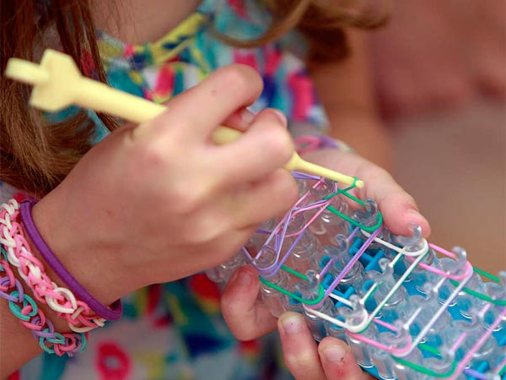At a Rainbow Loom class, Garrett Fill worked on a new bracelet. Garrett is 10 years old.

Garrett has a friend who is a girl. She is surprised that boys like Rainbow Looms. Garrett doesn’t see it that way at all.

He likes thinking up interesting patterns. He also likes using the colors of his favorite sports teams.

Garrett finished an orange, white, lime green and blue bracelet. He proudly looked at his work. “They make me look swag.”

In this article, the writer describes why the Rainbow Loom is popular with both boys and girls.

Write an original story about a boy or a girl who wants a Rainbow Loom. Make sure to use information from the article in your story.

________________________________________________________________________________________________________________________________________________________________________________________________________________________________________________________________________________________________________________________________________________________________________________________________________________________________________________________________________________________________________________________________________________________________________________________________________________________________________________________________________________

_____________________________________________________________________________________________________________________________________________________________________________________________________________________________________________________________________________________________________________________________________________________________________________________________________________________________________________________________________________________________________________________________________________________________________________________________________________________________________________________________________________________________________________________________________________________________________________________________________________________________________________________________________________________________