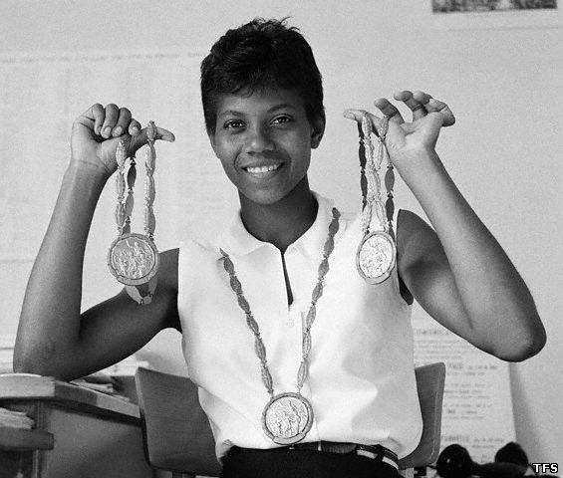

**WILMA RUDOLF:**

**Olympic Track Champion**

By Veronica Freeman Ellis

All eyes watched the little girl walking down the aisle. Wasn’t she Wilma Rudolph, who always wore a brace on her left leg? Yes, she was. But that Sunday morning in church, Wilma was walking without her brace. Everyone was surprised, but Wilma had always known that she would walk again someday.

“The Doctors told me that I would never walk,” said Wilma many years later, “but my mother told me I would, so I believed my mother.”

Wilma Rudolf was born in Bethlehem, Tennessee, in 1940. Just before her fifth birthday, Wilma became very ill. Her illness caused her to lose the use of her left leg.

Wilma was determined to walk. She did exercises every day to make her leg stronger. Even though doctors had put a steel brace on her leg, Wilma practiced walking every day without it. When she was twelve years old, she took off her brace for good.

At sixteen, Wilma Rudolph became the youngest member of the 1956 U.S. Olympic track team. That year she won a bronze medal in the relay race.

In 1960, Wilma became world famous. At the Olympics in Rome, Italy, she won a gold medal for the 100- meter dash. She won a second gold medal for the 200-meter dash.

It was time for the 400-meter relay race. Wilma was the final runner on her team. It was up to her to cross the finish line. When her teammate handed her the baton, Wilma nearly dropped it! Her team fell to third place, but Wilma didn’t give up. She ran as hard as she could- and she won.

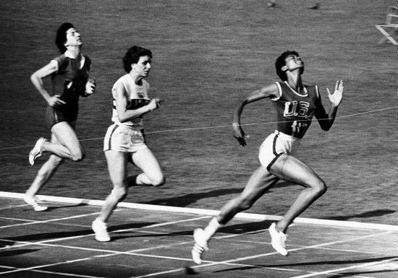

Wilma Rudolph became the first American woman to win three gold medals in track at the same Olympics. The little girl who had been told she would never walk was now the fastest runner in the world!

Wilma retired from running in 1962. She became a second grade teacher and a high school track coach. She started the Wilma Rudolph Foundation, which teaches young athletes that they, too, can be champions.

**In this passage, the author describes the life of athlete Wilma Rudolph.**

**Pretend you are Wilma Rudolph. Write an original story telling how your life changed after your braces came off. Be sure to use information from the passage in your story.**

________________________________________________________________________________________________________________________________________________________________________________________________________________________________________________________________________________________________________________________________________________________________________________________________________________________________________________________________________________________________________________________________________________________________________________________________________________________________________________________________________________

______________________________________________________________________________________________________________________________________________________________________________________________________________________________________________________________________________________________________________________________________________________________________________________________________________________________________________________________________________________________________________________________________________________________________________________________________________________________________________________________________________________________________________________________________________________________________________________________________________________________________________________________________________________________________________________________________