STANDARDS | RI.3.7 Use information gained from illustrations (e.g., maps, photographs) and the words in a text to demonstrate understanding of the text (e.g., where, when, why, and how key events occur).
Lesson Structure | High Yield Strategies | Lesson Plan
Goal  (2 minutes) | Setting Objective and Providing Feedback  Reinforcing effort and Providing Recognition | I can use illustrations and words in a text to help me understand what I read.  Students score themselves to the goal.
Access Prior Knowledge  (3minutes) | Nonlinguistic Representations  Cooperative Learning  Cues, Questions and Advance Organizers | Look at this picture. Tell your neighbor about this picture and what you think is happening.  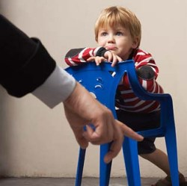  (Parent is setting rules to keep the child safe)  You were able to talk about this picture and give words to it to give more meaning.
New Information | Summarizing and Note Taking  Homework and Practice  Cues, Questions and Advance Organizers | We are going to read Monet .  Show students the picture on page 7. Discuss as a whole group what the students think is happening in the picture. Then show the text that goes along with it. Did the text help you to better understand the picture? Do you have a better idea of what is going on now that you have words and a picture?  Discuss how you really need both to best understand a picture.
Application | Indentifying Similarities and Differences  Cues, Questions and Advance Organizers  Homework and Practice  Cooperative Learning | Students will then work with a partner. They will need to be able to look at page 22 and 23 of the text. Have students work together to describe how the words and pictures work together so you can understand what is happening.  Next, students will individually respond as to how the pictures and captions on page 28 work together. Would you understand why there are two haystack pictures if the words were not there to help you understand? How do the pictures and words work together?
Goal | Setting Objective and Providing Feedback  Reinforcing effort and Providing Recognition | I can use illustrations and words in a text to help me understand what I read.  Students score themselves to the goal.

