 4th Grade, Unit 3

Creative, Inventive, and Notable People

Lewis and Clark

This activity is intended to provide an opportunity to engage students in the following standards:

* RI.4.2 Determine the main idea of a text and explain how it is supported by key details; summarize the text
* RI.4.4 Determine the meaning of general academic and domain-specific words or phrases in a text relevant to a grade 4 topic or subject area.
* L.4.4 Determine or clarify the meaning of unknown and multiple-meaning words and phrases based on grade 4 reading and content, choosing flexibly from a range of strategies
* Use context (e.g., definitions, examples, or restatements in text) as a clue to the meaning of a word or phrase.

The format for this lesson is aligned to the format for a portion of the “Research Simulation” on the PARCC Assessment. Students are asked to watch a video clip and answer questions about what they see and hear. On the PARCC test, students will then use information from the video and a passage (or passages) to write an essay about the major focus for all pieces combined

Teachers could use this activity as a whole-class teaching opportunity or as a formative assessment. Consider using this lesson in conjunction with *Lewis and Clark and Me* by Laurie Myers.

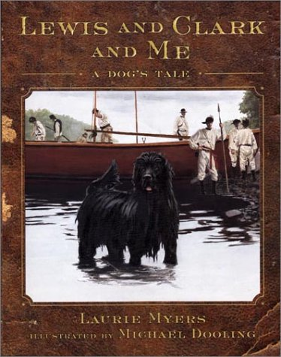

Checking for Understanding

BrainPop Video on “Lewis and Clark”

1. Part A

What does *presence* mean as it is used in the BrainPop video “Lewis and Clark”? (3:09-5:03)

* A. a gift or treasure given to someone else
* B. to see before hearing or touching
* C. a good friend or companion
* D. to be in existence or one’s company

Part B

Which statements from “Lewis and Clark” best represents benefits of having Sacagawea with their group? Choose all that apply.

* A. Her husband and child traveled with her.
* B. Women did not travel with Indian War Parties.
* C. Did not make food or medicine.
* D. Her tribe was attacked by a war party.
* E. She could speak several different languages.
* F. The group prepared to cross the Rocky Mountains.

1. Part A

Which of these statements **best** expresses a main idea from the video?

* A. Some Indian tribes were friendly while some were not.
* B. The Louisiana Purchased doubled the size of the United States with just the stroke of a

pen.

* C. Sacagawea translated for Lewis and Clark.
* D. Together, Lewis and Clark helped to discover unknown treasures across the United

States.

Part B

Which detail from the video supports the answer to Part A?

* A. “…Sacagawea and Charbonneau could speak several languages …” (2:40)
* B. “…inspired a whole movement of expansion…” (4:40)
* C. “Indian war parties never traveled with women or children...” (3:13)
* D. “…rest of the expedition finally arrived in St. Louis…” (4:06)

Checking for Understanding

BrainPop Video on “Lewis and Clark”

1. Part A

What does *presence* mean as it is used in the BrainPop video “Lewis and Clark”? (3:09-5:03)

* A. a gift or treasure given to someone else
* B. to see before hearing or touching
* C. a good friend or companion
* D. to be in existence or one’s company

Part B

Which statements from “Lewis and Clark” best represents benefits of having Sacagawea’s presence? Choose all that apply.

* A. Her husband and child traveled with her.
* B. Women did not travel with Indian War Parties.
* C. Did not make food or medicine.
* D. Her tribe was attacked by a war party.
* E. She could speak several different languages.
* F. The group prepared to cross the Rocky Mountains.

1. Part A

Which of these statements **best** expresses a main idea from the video?

* A. Some Indian tribes were friendly while some were not.
* B. The Louisiana Purchased doubled the size of the United States with just the stroke of a

pen.

* C. Sacagawea translated for Lewis and Clark.
* D. Together, Lewis and Clark helped to discover unknown treasures across the United

States.

Part B

Which detail from the video supports the answer to Part A?

* A. “…Sacagawea and Charbonneau could speak several languages …” (2:40)
* B. “…inspired a whole movement of expansion…” (4:40)
* C. “Indian war parties never traveled with women or children...” (3:13)
* D. “…rest of the expedition finally arrived in St. Louis…” (4:06)