**Winter's Tail**

By Shannon Teper  
Photos courtesy of Clearwater Marine Aquarium

INTRO

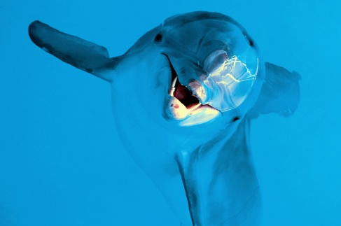

In Mosquito Lagoon, a two-month-old dolphin struggled to break free from the rope wrapped around her. Seeing a crab trap in the Florida waters, she had become curious and swum too close. The line attached to the trap coiled around her tail. The harder she pulled to swim away, the tighter the rope became.

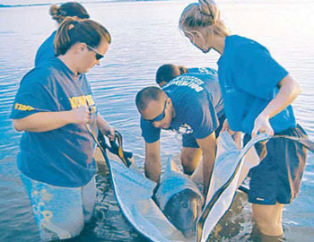

Luckily, a fisherman saw the injured baby dolphin and called for help. A rescue team brought the dolphin to the Clearwater Marine Aquarium in Florida. There the baby was given the name Winter.

**A Struggle to Survive**  
When she arrived, the flat part of Winter’s tail was thin and white, like paper. Over the next few weeks, it fell off. All that was left was a rounded stump where her tail had once been. No dolphin had ever survived losing an entire tail before.

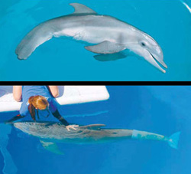

Winter was the first dolphin ever to get a completely new tail.

More than 150 volunteers and veterinarians cared for Winter around the clock. They fed her a special mix of baby formula and mashed-up fish. Winter grew healthier each day. She even learned to swim without a tail.

But Winter wasn’t swimming like a dolphin. Dolphins move their tails up and down. Since Winter had no tail, she whipped her whole body from side to side and swam like a shark. Veterinarians worried that Winter would injure her spine by twisting it in an unusual way.

**A New Tail for Winter**  
That’s when Kevin Carroll got involved. He heard Winter’s story on the radio and called the aquarium. He told them he made artificial limbs for animals. He had made body parts for dogs, an ostrich, and even a duck. Maybe he could make a tail for Winter. Winter had no tail at all. So Carroll designed a bendable plastic tail that would slip over the end of her body. A gel would be used to hold the artificial tail in place and protect Winter from getting sore when the tail rubbed against her skin.

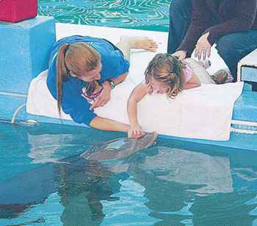

First, trainers helped Winter stretch and bend certain parts of her body, strengthening the muscles she needed to use for swimming. Then they attached her new tail, helping her learn how to move it up and down. Soon, Winter could use her new tail to swim like other dolphins.

Now, people from all over the world come to meet Winter. Her determination to swim with an artificial tail inspires visitors who also have disabilities.

Bailee Lorg from Knoxville, Tennessee, watched Winter splash and swim. “It’s great that she has a fake leg like me,” said the four-year-old. “I love her, and I’m so glad that we’re both special together.”