## Marian's Revolution

by Sudipta Bardhan-Quallen

By 1939, Marian Anderson had performed for presidents and kings. She had been praised for having "a voice ... one hears once in a hundred years." Despite her success, when Marian wanted to sing at Constitution Hall that year, she was banned from doing so. The owner of the hall, an organization called the Daughters of the American Revolution (DAR), felt that Marian couldn't be allowed to sing there because she was African American.

**Chosen by Music**

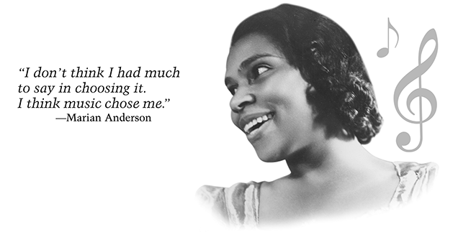That wasn't the first time Marian had been turned away because she was black. When she was 18 years old, she applied to music school. The clerk at the desk rudely sent her home because of her race. Marian was shocked by the clerk's words. "I could not conceive of a person," Marian said, "surrounded as she was with the joy that is music without having some sense of its beauty and understanding rub off on her."

Because of segregation—the practice of keeping blacks and whites separate—the early 1900s were a difficult time for a young black woman to begin a professional singing career. But Marian was determined to sing. "It was something that just had to be done," she remembered. "I don't think I had much to say in choosing it. I think music chose me."

In 1925, Marian won a voice contest in New York, and sang with the New York Philharmonic. Still, her chances to perform in the United States were limited. To build her career, Marian traveled to Europe in 1928, where she became very successful.

**A World-Class Singer Faces Racism**

By 1939, Marian was a world-class singer. She returned to the United States to continue her career. But back at home, she faced racism in many ways. Segregation was still common on trains and in hotels and restaurants. No amount of vocal talent could spare Marian from that. Even concert halls were segregated, although usually that was limited to the audience. Because black performers often appeared on stage in segregated halls, Marian had no reason to think she would be turned away from Constitution Hall. She believed that musical skill would be the only factor that the DAR would consider.

At first, the DAR told Marian that the date she requested was not available. Then they told her that all of her alternate dates were booked. Eventually, the DAR upheld their policy that only white performers could appear in Constitution Hall.

**A Voice for Civil Rights**

When news of the DAR's policy got out, many people were outraged. First Lady Eleanor Roosevelt resigned from the DAR. In a letter, she wrote: "I am in complete disagreement with the attitude taken in refusing Constitution Hall to a great artist .... You had an opportunity to lead in an enlightened way, and it seems to me your organization has failed."

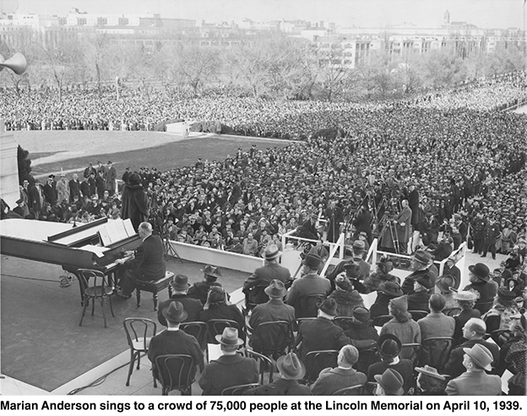Marian believed strongly in the civil rights movement. She knew firsthand the pain that racism caused. She understood that the way the controversy with the DAR was resolved would be a milestone for civil rights.

Despite public outcry, the DAR would not back down and let Marian sing. With Mrs. Roosevelt's support, the Secretary of the Interior arranged a special concert for Marian, to be held at the Lincoln Memorial. Seventy-five thousand people attended. In many ways, Marian's concert was considered to be America's first civil rights rally. That night, she took a stand against discrimination and for equality. The first words she sang were: "My country, 'tis of thee, sweet land of liberty, of thee I sing."

**The Open-Hearted Way**

Marian realized that equality in the United States would be achieved when every person was willing to stand up for what is right. As a public figure, she felt a responsibility to set an example. After the 1939 incident, she did her part by turning down concerts for segregated audiences.

"The minute a person whose word means a great deal dares to take the openhearted and courageous way," she said, ''many others follow."

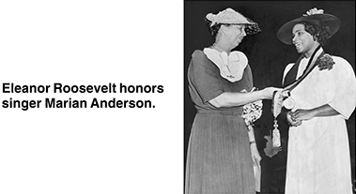As Marian's career progressed, America changed. She performed in many prestigious locations, including Constitution Hall, where she sang after the DAR changed its policies. By 1954, segregation was declared unconstitutional. The Civil Rights Act was signed into law in 1964, the year Marian retired from performing. By then, many of the barriers she'd had to fight through were disappearing. Marian's farewell tour began in front of an admiring crowd at Constitution Hall.

Copyright © 2005 Highlights for Children, Inc., Columbus, Ohio.

Photo credits for "Marian Anderson": Marian Anderson Collection, Rare Book and

Manuscript Library, University of Pennsylvania, Philadelphia, PA.

1. What is the article mainly about?
2. civil rights songs that Marian Anderson liked to sing
3. Marian Anderson’s friendship with Eleanor Roosevelt
4. how Marian Anderson learned to sing
5. how segregation affected Marian Anderson’s career
6. Why did Marian Anderson think she would be accepted to sing at Constitution Hall in 1939?
7. because she believed the DAR would consider only her musical skill
8. because she had sung at Constitution Hall before she went to Europe
9. because she thought that Eleanor Roosevelt would recommend her
10. because she knew that no other black singers had applied
11. On page 3 of the article, the author writes that Marian Anderson performed in many **prestigious** locations. This means that she sang in places that were
12. far away from each other
13. famous and important
14. open to people of all races
15. large and crowded

Why does the author begin and end the article talking about Constitution Hall? Use information from the article to support your answer.

Marian's Revolution

by Sudipta Bardhan-Quallen

TEACHER NOTES

* First read- blue questions (key ideas and details)
* Second read- orange questions (craft and structure)
* Third read (if necessary)- purple questions (integration of knowledge and ideas)

According to paragraph 1, what does DAR stand for? Why wouldn’t they let Marian sing at Constitution Hall?

By 1939, Marian Anderson had performed for presidents and kings. She had been praised for having "a voice ... one hears once in a hundred years." Despite her success, when Marian wanted to sing at Constitution Hall that year, she was banned from doing so. The owner of the hall, an organization called the Daughters of the American Revolution (DAR), felt that Marian couldn't be allowed to sing there because she was African American.

**Chosen by Music**

That wasn't the first time Marian had been turned away because she was black. When she was 18 years old, she applied to music school. The clerk at the desk rudely sent her home because of her race. Marian was shocked by the clerk's words. "I could not conceive of a person," Marian said, "surrounded as she was with the joy that is music without having some sense of its beauty and understanding rub off on her."

Why did the author use hyphens to separate the phrase “the practice of keeping blacks and whites separate”?

Because of segregation—the practice of keeping blacks and whites separate—the early 1900s were a difficult time for a young black woman to begin a professional singing career. But Marian was determined to sing. "It was something that just had to be done," she remembered. "I don't think I had much to say in choosing it. I think music chose me."

The passages says that Marian’s choice were limited. What choices is it referring to? Why were they limited? What did she do as a result of her limited choices?

In 1925, Marian won a voice contest in New York, and sang with the New York Philharmonic. Still, her chances to perform in the United States were limited. To build her career, Marian traveled to Europe in 1928, where she became very successful.

What is the main idea of the section titled “A World-Class Singer Faces Racism”? Support your answer with key details from the text.

**A World-Class Singer Faces Racism**

By 1939, Marian was a world-class singer. She returned to the United States to continue her career. But back at home, she faced racism in many ways. Segregation was still common on trains and in hotels and restaurants. No amount of vocal talent could spare Marian from that. Even concert halls were segregated, although usually that was limited to the audience. Because black performers often appeared on stage in segregated halls, Marian had no reason to think she would be turned away from Constitution Hall. She believed that musical skill would be the only factor that the DAR would consider.

At first, the DAR told Marian that the date she requested was not available. Then they told her that all of her alternate dates were booked. Eventually, the DAR upheld their policy that only white performers could appear in Constitution Hall.

What does “booked” mean as it is used in paragraph 6?

Why did the DAR tell Marian that the dates were not available? What were they hoping she would do?

**A Voice for Civil Rights**

Based on the words from Mrs. Roosevelt’s letter, what kind of person was she? What character traits describe her?

When news of the DAR's policy got out, many people were outraged. First Lady Eleanor Roosevelt resigned from the DAR. In a letter, she wrote: "I am in complete disagreement with the attitude taken in refusing Constitution Hall to a great artist .... You had an opportunity to lead in an enlightened way, and it seems to me your organization has failed."

What is a milestone? What words or phrases from the text helped you define the word?

Marian believed strongly in the civil rights movement. She knew firsthand the pain that racism caused. She understood that the way the controversy with the DAR was resolved would be a milestone for civil rights.

What does the phrase, “Despite public outcry” mean as it is used in the passage? What did the people want? How do you know?

Despite public outcry, the DAR would not back down and let Marian sing. With Mrs. Roosevelt's support, the Secretary of the Interior arranged a special concert for Marian, to be held at the Lincoln Memorial. Seventy-five thousand people attended. In many ways, Marian's concert was considered to be America's first civil rights rally. That night, she took a stand against discrimination and for equality. The first words she sang were: "My country, 'tis of thee, sweet land of liberty, of thee I sing."

Why was Marian’s concert at the Lincoln Memorial considered the first civil rights rally? Support your response with evidence from the text.

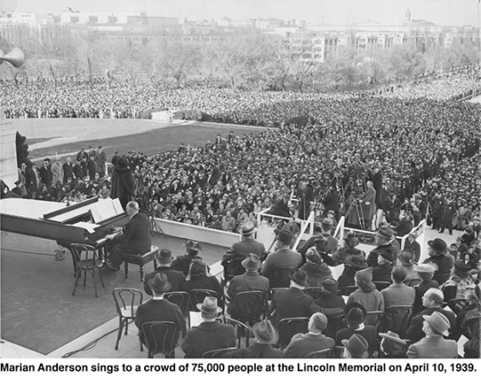**The Open-Hearted Way**

Marian realized that equality in the United States would be achieved when every person was willing to stand up for what is right. As a public figure, she felt a responsibility to set an example. After the 1939 incident, she did her part by turning down concerts for segregated audiences.

Why did Marian turn down concerts for segregated audiences? How was that “doing her part”?

"The minute a person whose word means a great deal dares to take the openhearted and courageous way," she said, ''many others follow."

As Marian's career progressed, America changed. She performed in many prestigious locations, including Constitution Hall, where she sang after the DAR changed its policies. By 1954, segregation was declared unconstitutional. The Civil Rights Act was signed into law in 1964, the year Marian retired from performing. By then, many of the barriers she'd had to fight through were disappearing. Marian's farewell tour began in front of an admiring crowd at Constitution Hall.

Why did the author choose to add this photograph to the section titled “A Voice for Civil Rights”? (photo is better placed in student copy)

What does the author mean by “barriers”? Which barriers did Marian fight through?



Copyright © 2005 Highlights for Children, Inc., Columbus, Ohio.

How is Marian Anderson a “creative” person? Use evidence from the passage to support your response.

Photo credits for "Marian Anderson": Marian Anderson Collection, Rare Book and

Written Response: Marian Anderson said, “The minute a person whose word means a great deal dares to take the openhearted and courageous way, many others follow.” What did she mean by this? How does this idea reflect her character? What does this say about the decisions she made after the DAR refused to let her sing at Constitution Hall?

Manuscript Library, University of Pennsylvania, Philadelphia, PA.

How do Marian Anderson’s actions make her a “notable” person? Use evidence from the passage to support your response.

1. What is the article mainly about?
2. civil rights songs that Marian Anderson liked to sing
3. Marian Anderson’s friendship with Eleanor Roosevelt
4. how Marian Anderson learned to sing
5. how segregation affected Marian Anderson’s career
6. Why did Marian Anderson think she would be accepted to sing at Constitution Hall in 1939?
7. because she believed the DAR would consider only her musical skill
8. because she had sung at Constitution Hall before she went to Europe
9. because she thought that Eleanor Roosevelt would recommend her
10. because she knew that no other black singers had applied
11. On page 3 of the article, the author writes that Marian Anderson performed in many **prestigious** locations. This means that she sang in places that were
12. far away from each other
13. famous and important
14. open to people of all races
15. large and crowded

Why does the author begin and end the article talking about Constitution Hall? Use information from the article to support your answer.

**Score & Description**

**Full Comprehension**

Responses at this level explain why the author both begins and ends the article talking about Constitution Hall and use information from the article as support.

* Because at the beginning of the story she was banned from singing at the Constitution Hall. At the end of the story, her farewell tour began in front of the Constitution Hall.
* At first she couldn't sing there, but then at the end she ended up singing there.

**Partial Comprehension**

a) Responses at this level may provide information from the article about Marian Anderson and/or Constitution Hall but do not explain why the author both begins and ends the article talking about Constitution Hall.

* That the DAR refused to let her sing in the Hall.
* Because Marian sang in Constitution Hall in 1964.

**OR**

b) Responses provide generalizations related to Marian Anderson singing at Constitution Hall but do not explain why the author begins and ends the article talking about Constitution Hall.

* She really wanted to sing there.
* Because Constitution Hall was an important place in Marian Anderson's life.

**Little or No Comprehension**

Responses at this level provide incorrect information, irrelevant details, or personal opinions. Responses may simply repeat the question.

* Because Marian started out singing at Constitution Hall.
* Because it is a historical landmark.
* I think because Marian is a good singer there.