

Grade 4 Reading

Sample Passages, Questions,

and Responses



This booklet contains sample items from the National Assessment of Educational Progress (NAEP). Additional items can be accessed at www.nces.ed.gov/nationsreportcard/itmrls.
SOURCE: U.S. Department of Education, Institute of Education Sciences, National Center for Education Statistics (NCES), National Assessment of Educational Progress (NAEP)

This test is posted at http://www.fldoe.org/asp/naep/

NAEP Reading Grade 4
Contents
Introduction 3
Passage 1, Tough as Daisy by David Simon 4
Passage 1, Question 1 - Infer aspect of major character 8
Passage 1, Question 2 - Interpret word as used in story 8
Passage 1, Question 3 - Evaluate how author reveals character feelings 9
Passage 1, Question 4 - Use paragraph to provide explanation 9
Passage 1, Question 5 - Contrast two story characters 11
Passage 2, Marian’s Revolution by Sudipta Bardhan-Quallen Error! Bookmark not defined.
Passage 2, Question 1 - Identify main idea of article Error! Bookmark not defined.
Passage 2, Question 2 - Recognize a relevant detail Error! Bookmark not defined.
Passage 2, Question 3 - Interpret word as used in article Error! Bookmark not defined.
Passage 2, Question 4 - Interpret the significance of an action Error! Bookmark not defined.
Passage 2, Question 5 - Evaluate author’s craft Error! Bookmark not defined.

Introduction
This practice grade 4 Reading test includes a sample of publicly released items from NAEP. Included with each item are the correct answer (indicated by an asterisk) and the distracters; the percentage of Florida’s responses to each of the possible answers; and the Description, Difficulty, and Complexity of each item.

Additional publicly released items and item data may be accessed through the NAEP Questions Tool (NQT) at http://nces.ed.gov/nationsreportcard/itmrlsx/default.aspx. The NQT is an interactive tool that provides access to over 2000 released questions from NAEP assessments in all NAEP subject areas. It is also used to access NAEP assessment items, their correct answers and distracters, and their scoring results by subject, grade, item type, difficulty, content classification, frameworks, year, and key words.

For more information about NAEP results, go to the NAEP Data Explorer (NDE) at http://nces.ed.gov/nationsreportcard/naepdata/. The NDE is an interactive tool that provides access to a wide variety of data about what students know and can do, as well as demographic and contextual factors that may affect their performance. The NDE produces charts, customized tables, and graphics based on NAEP results by year and jurisdiction; significance between jurisdictions, within variables, and across years; and gap analyses between jurisdictions or across years and between groups, between years, and between groups and years.

Additional information about the knowledge and skills the reading assessment is designed to measure can be found in the 2011 Reading Framework, http://www.nagb.org/publications/frameworks/reading-2011-framework.pdf. The current NAEP Reading Framework has guided the development of all Reading assessments since they began in 1992.

NAEP GRADE 4 READING
SAMPLE PASSAGES, QUESTIONS, AND RESPONSES

Passage 1
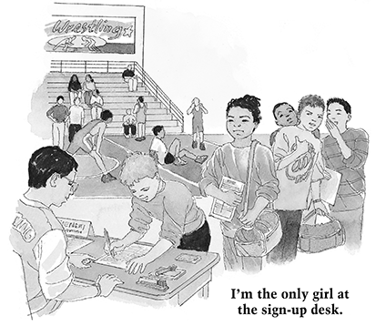

Tough as Daisy

by David M. Simon
The sign on the YMCA door says Wrestling Tournament Today.
I enter the gym and take a deep breath. It smells like old sweat socks and the stuff they use to wash wrestling mats.
I love that smell. Weird, huh? Not to me.
I was raised around wrestling. My older brothers wrestle for the high-school team. My dad wrestled in college. So it was natural for me to want to wrestle. Except for one thing.
I'm a girl. I even have a girly name—Daisy.
My dad always says, "Pound for pound, no one's as tough as Daisy."
I see my family in the stands. I wave to them and smile, but I'm nervous.
Lots of boys are already on the mats, loosening up. I'm the only girl at the sign-up desk. Some of the boys point at me and laugh. We'll see about that.
Back in Ohio, people got used to seeing me wrestle. I kept showing up. I kept winning. They stopped pointing and started cheering.
Then we moved to California. Now I'm weird again.
The man says, "Name?"
"Daisy McGill."
"Have you wrestled before, honey?"
He didn't call any of the boys honey. "Yes, sir," I answer through clenched teeth. I hand him my registration form.
"OK," he says. "Climb on the scale." I weigh 70 pounds. He writes a number on the back of my hand. I head to the girls' locker room to change.
First match. The kid looks strong. That's OK. Boys with muscles always underestimate me.
I snap the chin strap on my headgear. The ref calls us to the middle of the mat. We shake hands. The kid says, "I can't believe I have to wrestle a girl."
The whistle blows, and I hit him fast with a fireman's carry. He's on his back in three seconds. The ref's hand slaps the mat. Pinned. One match down.
The kid refuses to shake my hand. The ref raises my right arm. He tells me, "Beautiful takedown!"
There's a lot of whispering going on. I hear someone say, "Man, she pinned him fast. No girl is going to beat me."
My family cheers wildly. I feel good. It always takes one match for the butterflies in my stomach to settle.
They call my number for the next match.
People crowd around the mat to get a look at Bizarro Wrestler Girl. Sounds like a good name for a superhero!
This kid is tall and thin. He looks serious about winning.
The whistle blows. I shoot for his leg. He kicks back and snaps my head down. He spins around behind me and takes me down. Good. I love a challenge.
Final period of this match, and I'm down three to nothing. Time to make my move.
I escape for one point, then shoot a quick takedown. All tied up. Thirty seconds to go. He raises one leg and I take a chance. I reach around his head and knee. My hands close tight. I roll him onto his back.
The whistle blows. The ref holds up two fingers. I win by two points. Two matches down.
At least this kid shakes my hand. Some of the people watching even clap for me.
I'm in the finals for my weight class.
My brothers rub my arms and joke around with me. Dad says, "Just do your best, honey." It's OK when he calls me honey.
I head for the mat. The next kid I'm wrestling pinned both of his opponents. There's a huge crowd watching us. I can't tell if they want me to win or lose.
Doesn't matter to me.
We shake hands. "You're pretty good," he says. "Good luck."
"You, too," I say.
The whistle blows. He shoots, and I'm on my knees before I can blink. Wow, he's fast. I feel my heart hammering in my chest. Easy, Daisy.
I spin away. Escape. He misses an arm-drag, and I catch him flat-footed. Takedown.
After two periods we're all tied up.
We're both gulping for breath as the last period starts. My brothers are screaming, but they sound far away. The kid shoots for my legs. I flatten out. He has one leg hooked. I force my forearm across his face like a wedge. We're locked up tight.
I can see the clock ticking down. With ten seconds left, his arms relax. Just what I was waiting for. I push down and spin behind him for the win. Yes!
I hear cheering and realize it's for me. The kid says, "Nice match. But next time, I'm going to win." He just might.
My dad wraps my sweaty body in a big bear hug. He says, "Pound for pound, no one's as tough as Daisy."
I guess today he's right.
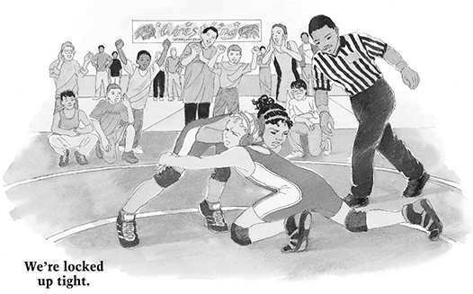
Copyright © 2006 Highlights for Children, inc., Columbus, Ohio.

Passage 1, Question 1
What is the main problem Daisy faces in this story?
- She has to make new friends at school.
- She has to perform in front of huge crowds.
- She has to prove that she is a good wrestler.
- She has to wrestle against strong boys.

Answers | Percent chosen by Florida’s participating students
*C | 58%
A | 2%
B | 4%
D | 36%

Description: Infer aspect of major character
Difficulty: Medium
Content Area: Literary
Cognitive Target: Integrate/Interpret

Passage 1, Question 2
On page 2 of the passage, Daisy says that she answered the man at the registration desk "through clenched teeth." This means that Daisy
- Had trouble speaking correctly
- Was nervous about joining the team
- Had hurt her teeth while wrestling
- Closed her teeth tightly when she spoke
Answers | Percent chosen by Florida’s participating students
*D | 62%
A | 4%
B | 30%
C | 4%

Passage 1, Question 2, continued
Description: Interpret word as used in story
Difficulty: Medium
Content Area: Literary
Cognitive Target: Integrate/Interpret

Passage 1, Question 3
What is the main way the author shows us how Daisy feels?
- He uses pictures to tell her story
- He tells what other people say about her
- He tells what she is thinking
- He describes the way she wrestles
Answers | Percent chosen by Florida’s participating students
*C | 44%
A | 8%
B | 20%
D | 27%

Description: Evaluate how author reveals character feelings
Difficulty: Medium
Content Area: Literary
Cognitive Target: Critique/Evaluate

Passage 1, Question 4
How did the people in Ohio feel about Daisy when she wrestled? Support your answer from the story.

Passage 1, Question 4, continued
Score & Description
Full Comprehension
Responses at this level explain how people in Ohio felt about Daisy when she wrestled and use information from the story as support. Responses discuss the change in the people's feelings.
- At first they were surprised but later they realized she was a good wrestler.
- In the beginning the people in Ohio thought it was strange that a girl was wrestling, but after she won some matches, they cheered for her.
- They got used to seeing her wrestle.
Partial Comprehension
Responses at this level explain how people in Ohio felt about Daisy at one point but do not discuss the change in their feelings.
- Everybody cheered for Daisy.
- They didn't think a girl could be a good wrestler.
- They supported her because she was a good wrestler.
- They thought she was weird.
Little or No Comprehension
Responses at this level provide irrelevant details, inaccurate story interpretations, or personal opinions. Or, they may simply repeat the question.
- They felt weird.
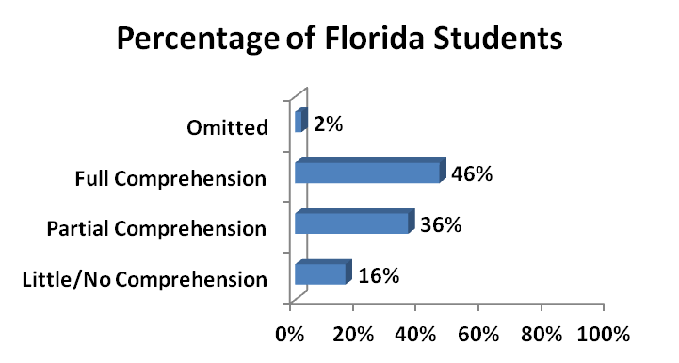

Passage 1, Question 4, continued
Description: Use paragraph to provide explanation
Difficulty: East
Content Area: Literary
Cognitive Target: Integrate/Interpret

Passage 1, Question 5
How is the first boy Daisy wrestles different from the last boy she wrestles? Support your answer with information from the story.

Score & Description
Comprehension
Responses at this level explain how the first boy Daisy wrestles is different from the last boy and support the answer with information from the story.
- The first boy was mean and didn't encourage her. The last boy told her "nice match" and actually shook her hand.
- The first boy was pinned to the ground in 3 seconds. The second boy was very tough and very persistent.
- The first one said I can't believe I have to face a girl and the other one said nice match but next time I will win.

Passage 1, Question 5, continued
Partial Comprehension
Responses at this level explain how the first boy Daisy wrestles is different from the last boy but make a general comparison and do not support the answer with information from the story. Some responses give a description of one boy but do not make a comparison.
- The first one was easy but the second one was very tough.
- The first boy Daisy wrestles was serious and the last boy she wrestled was kind and not mean.
Little or No Comprehension
Responses at this level provide an incorrect interpretation of the characters in the story or provide information only about Daisy. Or, they may simply repeat the question.
- The first one is not very sure about wrestling her because he thinks he is going to hurt her but the second one thinks he is going to win.
- Daisy is strong.
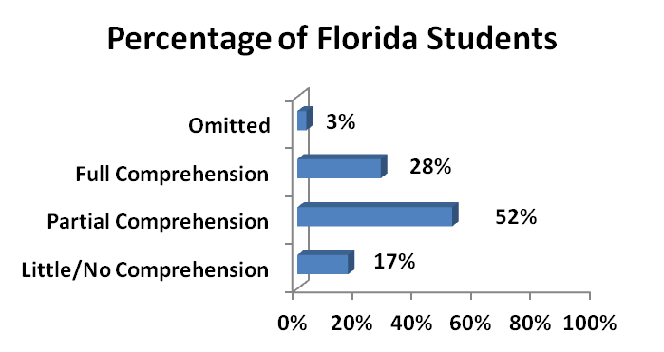

Description: Contrast two story characters
Difficulty: Medium
Content Area: Literary
Cognitive Target: Integrate/Interpret

Marian's Revolution
by Sudipta Bardhan-Quallen
By 1939, Marian Anderson had performed for presidents and kings. She had been praised for having "a voice ... one hears once in a hundred years." Despite her success, when Marian wanted to sing at Constitution Hall that year, she was banned from doing so. The owner of the hall, an organization called the Daughters of the American Revolution (DAR), felt that Marian couldn't be allowed to sing there because she was African American.
Chosen by Music
That wasn't the first time Marian had been turned away because she was black. When she was 18 years old, she applied to music school. The clerk at the desk rudely sent her home because of her race. Marian was shocked by the clerk's words. "I could not conceive of a person," Marian said, "surrounded as she was with the joy that is music without having some sense of its beauty and understanding rub off on her."

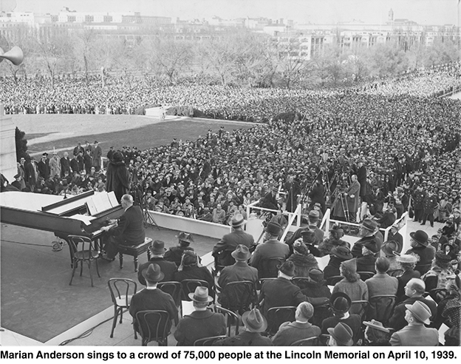
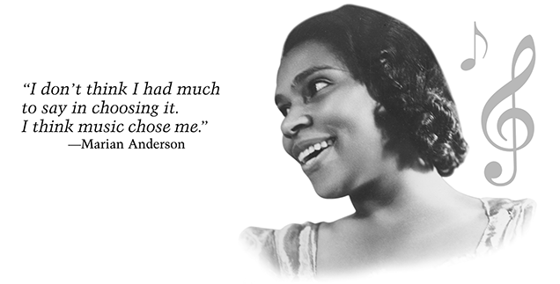
Because of segregation—the practice of keeping blacks and whites separate—the early 1900s were a difficult time for a young black woman to begin a professional singing career. But Marian was determined to sing. "It was something that just had to be done," she remembered. "I don't think I had much to say in choosing it. I think music chose me."
In 1925, Marian won a voice contest in New York, and sang with the New York Philharmonic. Still, her chances to perform in the United States were limited. To build her career, Marian traveled to Europe in 1928, where she became very successful.
A World-Class Singer Faces Racism
By 1939, Marian was a world-class singer. She returned to the United States to continue her career. But back at home, she faced racism in many ways. Segregation was still common on trains and in hotels and restaurants. No amount of vocal talent could spare Marian from that. Even concert halls were segregated, although usually that was limited to the audience. Because black performers often appeared on stage in segregated halls, Marian had no reason to think she would be turned away from Constitution Hall. She believed that musical skill would be the only factor that the DAR would consider.
At first, the DAR told Marian that the date she requested was not available. Then they told her that all of her alternate dates were booked. Eventually, the DAR upheld their policy that only white performers could appear in Constitution Hall.
A Voice for Civil Rights
When news of the DAR's policy got out, many people were outraged. First Lady Eleanor Roosevelt resigned from the DAR. In a letter, she wrote: "I am in complete disagreement with the attitude taken in refusing Constitution Hall to a great artist .... You had an opportunity to lead in an enlightened way, and it seems to me your organization has failed."
Marian believed strongly in the civil rights movement. She knew firsthand the pain that racism caused. She understood that the way the controversy with the DAR was resolved would be a milestone for civil rights.
Despite public outcry, the DAR would not back down and let Marian sing. With Mrs. Roosevelt's support, the Secretary of the Interior arranged a special concert for Marian, to be held at the Lincoln Memorial. Seventy-five thousand people attended. In many ways, Marian's concert was considered to be America's first civil rights rally. That night, she took a stand against discrimination and for equality. The first words she sang were: "My country, 'tis of thee, sweet land of liberty, of thee I sing."
The Open-Hearted Way
Marian realized that equality in the United States would be achieved when every person was willing to stand up for what is right. As a public figure, she felt a responsibility to set an example. After the 1939 incident, she did her part by turning down concerts for segregated audiences.
"The minute a person whose word means a great deal dares to take the openhearted and courageous way," she said, ''many others follow."
As Marian's career progressed, America changed. She performed in many prestigious locations, including Constitution Hall, where she sang after the DAR changed its policies. By 1954, segregation was declared unconstitutional. The Civil Rights Act was signed into law in 1964, the year Marian retired from performing. By then, many of the barriers she'd had to fight through were disappearing. Marian's farewell tour began in front of an admiring crowd at Constitution Hall.
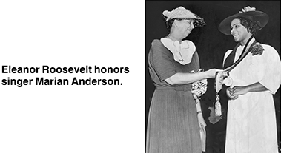
Copyright © 2005 Highlights for Children, Inc., Columbus, Ohio.
Photo credits for "Marian Anderson": Marian Anderson Collection, Rare Book and
Manuscript Library, University of Pennsylvania, Philadelphia, PA.

- What is the article mainly about?
- civil rights songs that Marian Anderson liked to sing
- Marian Anderson’s friendship with Eleanor Roosevelt
- how Marian Anderson learned to sing
- how segregation affected Marian Anderson’s career

- Why did Marian Anderson think she would be accepted to sing at Constitution Hall in 1939?
- because she believed the DAR would consider only her musical skill
- because she had sung at Constitution Hall before she went to Europe
- because she thought that Eleanor Roosevelt would recommend her
- because she knew that no other black singers had applied

- On page 3 of the article, the author writes that Marian Anderson performed in many prestigious locations. This means that she sang in places that were
- far away from each other
- famous and important
- open to people of all races
- large and crowded

Why do you think Marian Anderson began her concert singing the words, “My country, tis of thee, sweet land of liberty, of thee I sing”? Give evidence from the passage to support your answer.

Score & Description
Full Comprehension
Responses at this level explain why Marian Anderson started the concert this way and connect the song to the civil rights movement and use information from the article as support.
- I think she began her concert like that so people could know that African American people live there too and they should be treated the same.
- Because she wanted for people to be treated with equality and to stand against discrimination for everyone.
- Because she wanted to show people that segregation was not right.
Partial Comprehension
Responses at this level provide a fact about Marian Anderson or the song, but they do not connect the song to the civil rights movement.
- Marian Anderson wanted to be a singer in Constitution Hall.
- Because it is a song that inspires us a lot.
- I think she started with those words because she loved her country and she wanted everyone to know it.
- She was singing about the whole U.S.A.
- Marian thought that all blacks should be free.
Little or No Comprehension
Responses at this level provide incorrect information, irrelevant details, or unsupported personal opinions. Responses may simply repeat the question.
- It was the first song she learned.
- Because Marian likes to sing and is a good singer.
- Because she thought that it would be good to start it like that.

Why do you think the author begins and ends the article talking about Constitution Hall? Use information from the article to support your answer.

Score & Description
Full Comprehension
Responses at this level explain why the author both begins and ends the article talking about Constitution Hall and use information from the article as support.
- Because at the beginning of the story she was banned from singing at the Constitution Hall. At the end of the story, her farewell tour began in front of the Constitution Hall.
- At first she couldn't sing there, but then at the end she ended up singing there.
Partial Comprehension
a) Responses at this level may provide information from the article about Marian Anderson and/or Constitution Hall but do not explain why the author both begins and ends the article talking about Constitution Hall.
- That the DAR refused to let her sing in the Hall.
- Because Marian sang in Constitution Hall in 1964.
OR
b) Responses provide generalizations related to Marian Anderson singing at Constitution Hall but do not explain why the author begins and ends the article talking about Constitution Hall.
- She really wanted to sing there.
- Because Constitution Hall was an important place in Marian Anderson's life.
Little or No Comprehension
Responses at this level provide incorrect information, irrelevant details, or personal opinions. Responses may simply repeat the question.
- Because Marian started out singing at Constitution Hall.
- Because it is a historical landmark.
- I think because Marian is a good singer there.

