Childhood Story of Amelia Earhart
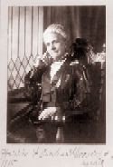  Harriet Earhart Monroe | 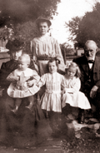  Grandma Amelia Otis,  Otis Balis, Annie Otis,  Muriel Earhart Morrissey,  Amelia Earhart &  Grandpa Gideon Otis | 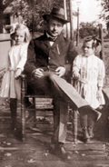  Amelia Earhart, Mark Otis & Muriel Earhart Morrisey | 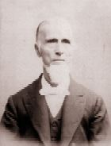  Rev. David Earhart, Grandfather


As a child, she spent the winter months with her grandparents in Atchison and the summers with her parents in Kansas City, Kansas. Earhart's grandparents, Alfred and Amelia Otis were well off, and although Amelia would know some financial hardship in her teens and twenties, her early life were spent in the midst of plenty. Alfred Otis was a retired U.S. District Court Judge, president of the Atchison Savings Bank, and chief warden of Trinity Episcopal Church.
Amelia attended a private college preparatory school, where, although she loved to read, she sometimes got into trouble as a result of her independent nature. Her mother and younger sister, Muriel, often came to Atchison to visit, but Amelia seldom saw her father during these years. The Earhart family moved to Des Moines, Iowa, when Amelia was in the seventh grade.
By Earhart's own account, her childhood activities suggested she would lead an active adulthood. While the social standards of the time held that young girls should behave in a genteel and ladylike fashion, young Amelia was interested in adventure. She recalled being fascinated by mechanical things, and she once designed a trap to catch stray chickens. As the daughter of a railroad employee, she traveled often and thus "discovered the fascination of new people and new places." She also realized early that boys were under fewer constraints than girls and questioned why. She liked "all kinds of sports and games" and was willing to try even those games adults considered only for boys.
Close Reading Questions

1st Read - Write the main idea of each section.

2nd Read – In the 1st section, the author said Amelia’s grandparents were well off. What does the words well off mean? Underline the phrases that helped you understand the meaning of the words.

3rd Read- Some people would say that Amelia Earhart was ahead of the times or innovative. How does this passage show she was ahead of her time?
OR
What does reading about Amelia Earhart’s childhood help you understand her adulthood better?

