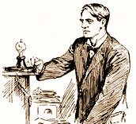3rd Grade, Unit 3

Creative, Inventive, and Notable People

Frida Kahlo

This activity is intended to provide an opportunity to engage students in the following standards:

* RI.3.4 Determine the meaning of general academic and domain-specific words and phrases in a text relevant to a grade 3 topic or subject area.
* RI.3.2 Determine the main idea of a text; recount the key details and explain how they support the main idea.
* SL.3.2 Determine the main ideas and supporting details of a text read aloud or information presented in diverse media and formats, including visually, quantitatively, and orally.

The format for this lesson is aligned to the format for a portion of the “Research Simulation” on the PARCC Assessment. Students are asked to watch a video clip and answer questions about what they see and hear. On the PARCC test, students will then use information from the video and a passage (or passages) to write an essay about the major focus for all pieces combined. At this time, the Research Simulation for 3rd grade is not available to view on the PARCC Practice Tests, so this format was modeled after the questions on the 4th and 5th grade practice tests.

Teachers could use this activity as a whole-class teaching opportunity or as a formative assessment. Consider using this lesson in conjunction with *Frida Kahlo: The Artist Who Painted Herself* by Margaret Frith.

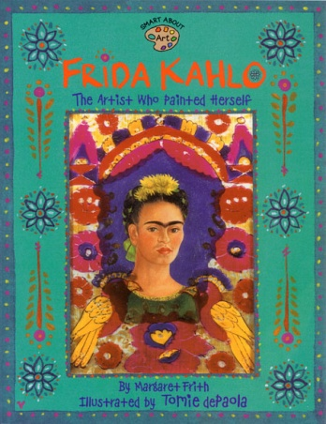

Checking for Understanding

BrainPop Video on “Frida Kahlo”

1. Part A

What does *peasant* mean as it is used in the BrainPop video “Frida Kahlo”? (0:51-1:14)

* A. a poor person of low social status
* B. pleasing; agreeable
* C. a person who cannot paint
* D. soldier

Part B

Which statement from “Frida Kahlo” best supports the answer to Part A?

* A. “…armed groups…”
* B. “…during the Mexican revolution…”
* C. “…better living conditions…”
* D. “…became a strong supporter…”

1. Frida Kahlo once said, “I am not sick. I am broken. But I am happy as long as I can paint.” Which of the following events from her life may have led her to feel this way? Check all that apply.

* A. Kahlo’s father encouraged her to play sports.
* B. Kahlo witnessed a number of bloody struggles.
* C. At age 7, Polio weakened the muscles in her right leg.
* D. She was a supporter of peasants’ rights.
* E. 55 or the 143 paintings she completed were self-portraits.
* F. She painted her head on the body of a stag.
* G. Diego Rivera may have only loved the Mexican part of her.
* H. One of her legs had to be amputated.

Checking for Understanding

BrainPop Video on “Frida Kahlo”

1. Part A

What does *peasant* mean as it is used in the BrainPop video “Frida Kahlo”? (0:51-1:14)

* A. a poor person of low social status
* B. pleasing; agreeable
* C. a person who cannot paint
* D. soldier

Part B

Which statement from “Frida Kahlo” best supports the answer to Part A?

* A. “…armed groups…”
* B. “…during the Mexican revolution…”
* C. “…better living conditions…”
* D. “…became a strong supporter…”

1. Frida Kahlo once said, “I am not sick. I am broken. But I am happy as long as I can paint.” Which of the following events from her life may have led her to feel this way? Check all that apply.

* A. Kahlo’s father encouraged her to play sports.
* B. Kahlo witnessed a number of bloody struggles.
* C. At age 7, Polio weakened the muscles in her right leg.
* D. She was a supporter of peasants’ rights.
* E. 55 or the 143 paintings she completed were self-portraits.
* F. She painted her head on the body of a stag.
* G. Diego Rivera may have only loved the Mexican part of her.
* H. One of her legs had to be amputated.