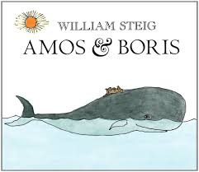Narrative Writing Task

Unit 2 (following the reading of Amos & Boris & Text Talk)

William Steig ends the story of “Amos & Boris” by saying…

“He looked back at Amos on the elephant’s head. Tears were rolling down the great whale’s cheeks. The tiny mouse had tears in his eyes too. “Goodbye, dear friend,” squeaked Amos. “Goodbye, dear friend,” rumbled Boris, and he disappeared in the waves. They knew they might never meet again. They knew they would never forget each other.”

Imagine one day Amos and Boris met again. Write a story to tell about their reunion. Use what you know about the characters and story elements to tell about what would happen and how each of the characters would feel about their reunion.