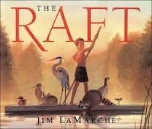Name: _______________________________________

The Raft by Jim LaMarche

Look at the picture and read the text from the story, The Raft.

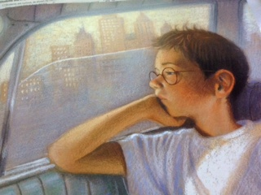

*“There is nobody to play with,” I complained. “She doesn’t even have a TV.” Dad grinned. “Well, she’s not your normal kind of grandma, I guess,” he said. “You know I can’t take you with me this summer, Nicky. There’ll be no kids there, and I’ll be spending all my time at the plant.”*

*I felt tears starting again, but I blinked hard and looked out the window.*

Why did the author/illustrator choose to put this picture of Nikky with the text above? What do you know about Nikky after reading this part of the text and seeing the picture?

__________________________________________________________________________________________________________________________________________________________________________________________________________________________________________________________________________________________________________________________________________________________________________________________________________________