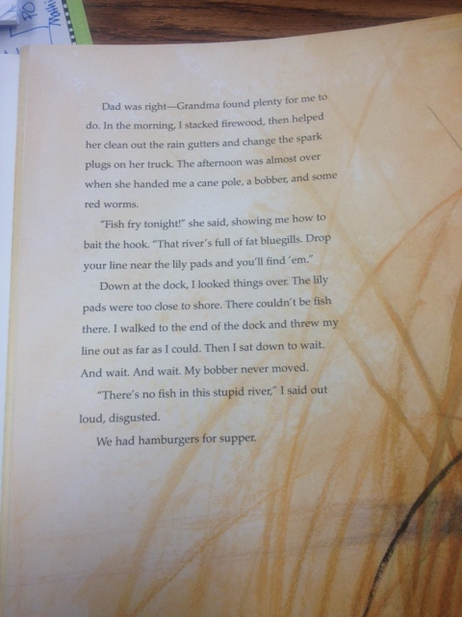

TEACHER NOTES

* Highlighted words are possible vocabulary words for this passage. Let students identify which words they do not understand. If possible, work as a class to use context clues and/or illustrations to determine meaning.
* First read- blue questions (key ideas and details)
* Second read- orange questions (craft and structure)
* Third read (if necessary)- purple questions (integration of knowledge and ideas)

Grandma helped with the rain gutters and the spark plugs…why did she all of a sudden HAND Nicky the cane pole, bobber, and red worms? (PoV)

Dad was right-Grandma found plenty for me to do. In the morning, I stacked firewood, then helped her clean out the rain gutters and change the spark plugs on her truck. The afternoon was almost over when she handed me a cane pole, a bobber, and some red worms.

What are these things? Do I REALLY need to understand them to fully comprehend the story? Are they important on later pages of this book?

Grandma tells Nicky to drop his line near the lily pads, but Nicky says there can’t be any fish there…who is right?

What chores does Grandma have Nicky do?

“Fish fry tonight!” she said, showing me how to bait the hook. “That river’s full of fat bluegills. Drop your line near the lily pads and you’ll find ‘em.”

Down at the dock, I looked things over. The lily pads were too close to shore. There couldn’t be fish there. I walked to the end of the dock and threw my line out as far as I could. Then I sat down to wait. And wait. And wait. My bobber never moved.

Why did Jim LaMarch repeat the word “wait” three times? What does that help you, the reader, to know?

When Nicky says, “My bobber never moved,” what does he mean?

“There’s no fish in this stupid river,” I said out loud, disgusted.

How does Nicky feel now? How do you know?

We had hamburgers for supper.

Why is this story in our unit titled “Inspired by the Sea?” How does it support our essential question? (Why does the sea inspire writers?)

How might things have been different if Grandma had gone fishing? (PoV)

Wait a minute…hamburgers? I thought Grandma said they were having a fish fry…

