STANDARDS | RL.3.6 Distinguish their own point of view from that of the narrator or those of the characters.  This should be done as a separate lesson with The Raft (after students have heard it at least once). This lesson looks at the second part of this standard; p.o.v. of narrator or character.
P.O.V.  Definition | Being able to determine the point of view in which the author has written the text. The reader needs to know the point of view of the writer because of the way it impacts the story/writing.
Materials | Text, The Raft Jim LaMarche; Power Point on P.O.V.
Lesson Structure | High Yield Strategies |  | Lesson Plan
Goal | (8) Setting Objective and Providing Feedback |  | I can determine point of view.
Access Prior Knowledge | (6) Nonlinguistic Representations  (7) Cooperative Learning  (10) Cues, Questions and Advance Organizers |  | Use the power point; the first slide is the APK;  Showing different things we use to see.  What do you we use these objects to do?
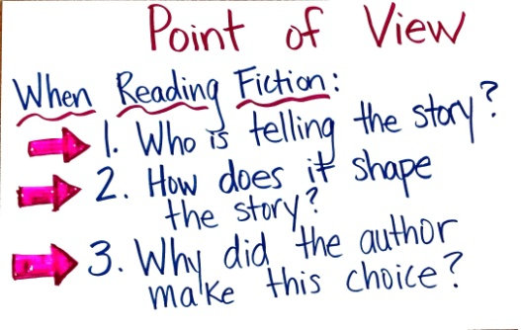  New Information | (3) Summarizing and Note Taking  (5) Homework and Practice  (11) Teaching Specific Types of Knowledge |  | - Take students through power point and pictures of the lake and sky; pay close attention to the notes on the bottom of the slide.  - Use the term of perspective through the slides of the sky  - Definition of Point of View slide: have students read together.  - When reading a text; there are 3 facts we need to know:  - Identify the point of view; Who is telling the story?  (eyes back on text; look at “I” and “my”; that is how we know it is Nikky)  - How does it shape the story? (we get to know how Nikky feels; eyes on the text shows the words he used: stupid, disgusted)  - Why did the author make this choice? (we get to see how Nikky’s perspective changed through the story; but the point of view of the story did not change)  (Use the notes from the PPT slide to help guide through these questions.)  Students will see that a person’s perspective can change; but, the point of view from which the story is written does not change.
Application | Declarative  (2) Indentifying Similarities and Differences  (3)Generating and Testing Hypotheses  (10) Cues, Questions and Advance Organizers | Procedural  (5) Homework and Practice | Now it’s your turn….  Students can either write in their notebooks, discuss as a class or use the handout to answer this question:  “How would the story have changed if it were from the grandma’s point of view?”
Goal | (8) Setting Objective and Providing Feedback  (4) Reinforcing effort and Providing Recognition |  | Revisit the Goal; Score Yourselves on Understanding

