Grandfather’s Journey by Allen Say

(Last page of the text)

After a time, I came to love the land my grandfather had loved, and I stayed on and on until I had a daughter of my own.

But I also miss the mountains and rivers of my childhood. I miss my old friends. So I return now and then when I cannot still the longing in my heart.

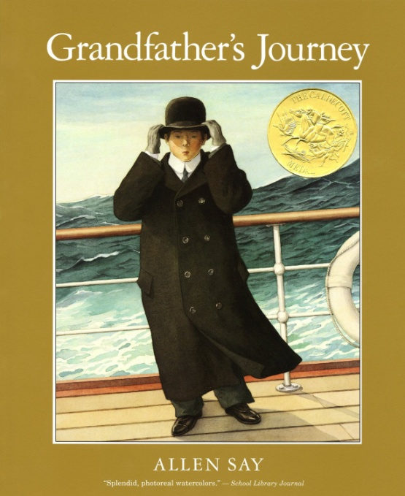The funny thing is, the moment I am in one country, I am homesick for the other.

Teacher Notes

Copy the page for the students. Have them read and discuss words or phrase that are confusing. As much as possible, have students use the surrounding text to help determine meaning. Make notes on the passage as you go along.

Sample questions to jump start discussion

* “…I stayed on and on…” What does this mean?
* “…when I cannot still the longing in my heart.” What does this mean?
* What does he mean by “funny”?
* “Homesick for the other” what?