Think about the Wild West. Fill in the circle that shows the best picture of the word.

Aimlessly

|  |  |  |
| --- | --- | --- |
| http://thumb7.shutterstock.com/display_pic_with_logo/2066474/182840909/stock-vector-black-footprints-that-confused-and-aimless-wandering-in-the-white-area-white-background-vector-182840909.jpg | http://www.drbrand.ca/latest/wp-content/uploads/2014/05/bullseye.jpg | http://www.picturesof.net/_images_300/Skinny_Cow_Grazing_Royalty_Free_Clipart_Picture_081231-223178-673042.jpg |

Chuck wagon

|  |  |  |
| --- | --- | --- |
| http://etc.usf.edu/clipart/63200/63274/63274_farm_animals_lg.gif | http://www.picturesof.net/_images_300/Skinny_Cow_Grazing_Royalty_Free_Clipart_Picture_081231-223178-673042.jpg | http://yemerriegreenwoodfaire.org/gw_mysteries/images/clipart/chuckwagon.jpg |

Corral

|  |  |  |
| --- | --- | --- |
| http://ec.l.thumbs.canstockphoto.com/canstock11492166.jpg | http://etc.usf.edu/clipart/63200/63274/63274_farm_animals_lg.gif | http://sr.photos3.fotosearch.com/bthumb/CSP/CSP199/k20964619.jpg |

Grazing

|  |  |  |
| --- | --- | --- |
| http://thumb7.shutterstock.com/display_pic_with_logo/2066474/182840909/stock-vector-black-footprints-that-confused-and-aimless-wandering-in-the-white-area-white-background-vector-182840909.jpg | http://www.picturesof.net/_images_300/Skinny_Cow_Grazing_Royalty_Free_Clipart_Picture_081231-223178-673042.jpg | http://www.drbrand.ca/latest/wp-content/uploads/2014/05/bullseye.jpg |

Cookie

|  |  |  |
| --- | --- | --- |
| http://previews.123rf.com/images/memoangeles/memoangeles1401/memoangeles140100013/25298239-Wolf-disguised-as-and-old-woman-Vector-clip-art-illustration-with-simple-gradients-All-in-a-single-l-Stock-Vector.jpg | http://images.clipartpanda.com/cookie-clipart-black-and-white-bitten-biscuit-clipart-biscuit.png | https://s-media-cache-ak0.pinimg.com/736x/56/79/7e/56797e0b8064d9ee87dd7958a2360fc7.jpg |

Lasso

|  |  |  |
| --- | --- | --- |
| https://s-media-cache-ak0.pinimg.com/736x/56/79/7e/56797e0b8064d9ee87dd7958a2360fc7.jpg | http://sr.photos3.fotosearch.com/bthumb/CSP/CSP199/k20964619.jpg | http://thumbs.dreamstime.com/z/cowboy-lasso-5560386.jpg |

Brand

|  |  |  |
| --- | --- | --- |
| http://www.jauerangus.com/images/freeze%20brand/889.jpg | http://thumbs.dreamstime.com/z/cowboy-lasso-5560386.jpg | http://www.practicatechnical.com/files/scans_bw/Animals/Cattle/Stampede.png |

Stampede

|  |  |  |
| --- | --- | --- |
| http://www.practicatechnical.com/files/scans_bw/Animals/Cattle/Stampede.png | https://s-media-cache-ak0.pinimg.com/736x/56/79/7e/56797e0b8064d9ee87dd7958a2360fc7.jpg | http://www.jauerangus.com/images/freeze%20brand/889.jpg |

Disguise

|  |  |  |
| --- | --- | --- |
| http://www.drbrand.ca/latest/wp-content/uploads/2014/05/bullseye.jpg | http://www.jauerangus.com/images/freeze%20brand/889.jpg | http://previews.123rf.com/images/memoangeles/memoangeles1401/memoangeles140100013/25298239-Wolf-disguised-as-and-old-woman-Vector-clip-art-illustration-with-simple-gradients-All-in-a-single-l-Stock-Vector.jpg |

Clinging

|  |  |  |
| --- | --- | --- |
| http://ec.l.thumbs.canstockphoto.com/canstock11492166.jpg | http://www.picturesof.net/_images_300/Skinny_Cow_Grazing_Royalty_Free_Clipart_Picture_081231-223178-673042.jpg | http://thumb7.shutterstock.com/display_pic_with_logo/2066474/182840909/stock-vector-black-footprints-that-confused-and-aimless-wandering-in-the-white-area-white-background-vector-182840909.jpg |

Fetch

|  |  |  |
| --- | --- | --- |
| http://sr.photos3.fotosearch.com/bthumb/CSP/CSP199/k20964619.jpg | http://etc.usf.edu/clipart/63200/63274/63274_farm_animals_lg.gif | http://previews.123rf.com/images/memoangeles/memoangeles1401/memoangeles140100013/25298239-Wolf-disguised-as-and-old-woman-Vector-clip-art-illustration-with-simple-gradients-All-in-a-single-l-Stock-Vector.jpg |

Listen to these sentences as your teacher reads them aloud. Fill in the circle for the sentence with the underlined word used correctly.

* The teacher beckons the crying student to her.
* The beckons car stopped at the light.
* My capture ate a sandwich.
* What will happen if he captures a tiger?
* The horse slid into a ravine.
* The ravine flew through the sky.
* Could you pick up a gallop of milk at the store?
* The startled giraffe took off at a gallop.
* The cold scurries shake the leaves from the trees.
* The frightened mouse scurries away from the trap.
* When I slithered onto the airplane, I knew it would be a fun flight!
* The dog growled and the snake slithered away.
* We are fortunate to have breakfast in the classroom.
* The fortunate teller said I would be rich.
* We could see the thunderous mountains from the highway.
* I am not afraid of thunderous storms.
* I urge you to take good care of your teeth.
* When your urge itches, try not to scratch.
* If your goldfish gulps, you have to flush him down the toilet.
* Try not to gulp your drink or you might get the hiccups.
* Every time the bull charges that clown he gets him!
* If you don’t charge your pizza it won’t get warm.

Read the sentences. Fill in the circle that best matches the meaning of the underlined word.

Magic Rick’s tricks are astonishing.

* Surprising
* Easy
* Cool
* Boring

The solemn kindergartener showed us her bloody knee.

* Excited
* Crying
* Serious
* Proud

Don’t you think cupcakes are scrumptious?

* Junk food
* Sweet
* Chocolate
* Delicious

The angry bees came streaming out of the hive.

* Flying
* Pouring
* Together
* Buzzing

The unhappy woman trudged across the parking lot.

* Pushed
* Walked
* Drove
* Yelled

The homeless dog just wanders the streets.

* Walks around
* Barks
* Runs across
* Chases

The wild horse bolted across the field when he saw me.

* Ran away
* Jumped
* Came
* Followed

I am glad my grandparents settled in Arkansas.

* Got married
* Moved
* Lived
* Came to stay

Circle three examples of **collective nouns**.

Sheep Cattle Herd School Wolves Geese Flock

Circle three examples of **settings**.

The woods Soccer Grandma’s house Long ago Sister

Circle two examples of a **tall tale**.

Pecos Bill Paul Bunyan Little Red Riding Hood Cinderella

Where in a story do you find the **conclusion**?

Read the following sentences. Each sentence has a word missing. Fill in the circle to show which word best completes the sentence.

He studied the iPad .

* Intently
* Reluctant
* Wrangle

I would love to spend a summer learning how to wild horses.

* Intently
* Reluctant
* Wrangle

It makes me sad to hear a student say they are to read.

* Intently
* Reluctant
* Wrangle

Write the numbers in the boxes that match the picture below.

1. Hat

2. Boots

3. Stirrup

4. Saddle

5. Rope

6. Bit

7. Spurs

8. Chaps

9. Reins

10. Bridle or harness

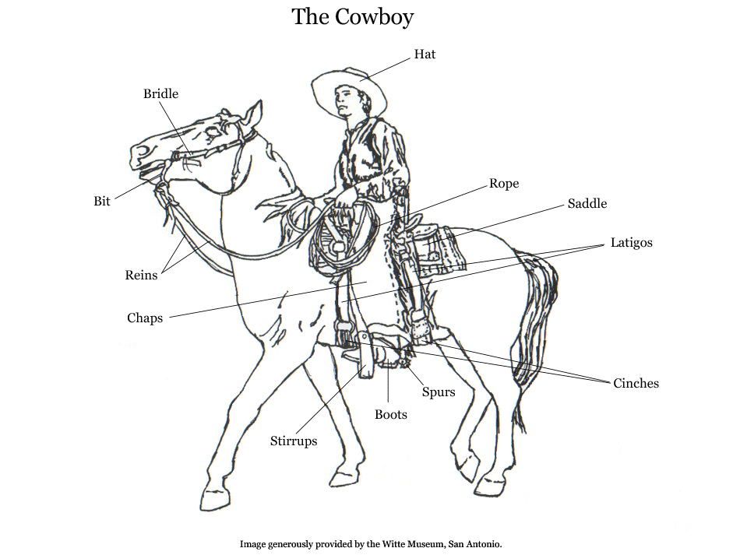

[Type a quote from the document or the summary of an interesting point. You can position the text box anywhere in the document. Use the Text Box Tools tab to change the formatting of the pull quote text box.]