Fill in the circle that shows the best picture of the word.

Weary
 |  | 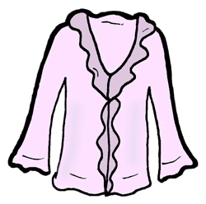

Luscious
 | 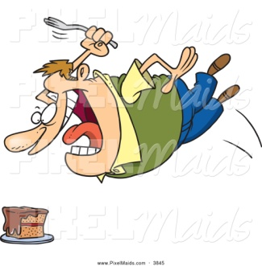 | 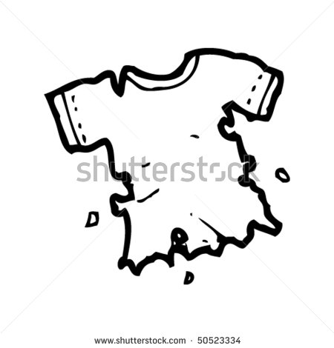

Miserable
 |  | 

Devastate

Tattered
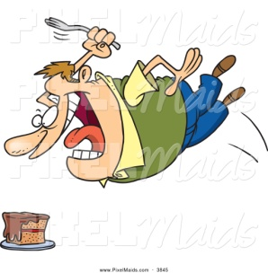 | 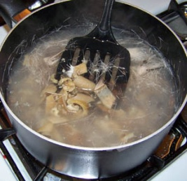

Aroma
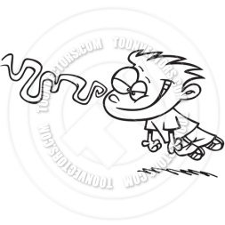 |  | 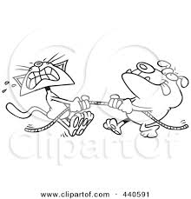

Furious


Gather
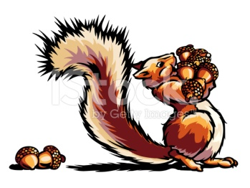

Scorch
 | 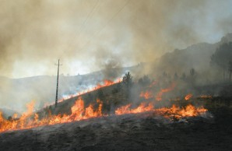

Simmer


Aghast


Listen to these sentences as your teacher reads them aloud. Fill in the circle for the sentence with the bold word used correctly.

- Students at Grace Hill assemble in the cafeteria.
1.
- The assemble for High Flyer awards will be in two weeks.

- The peasants mostly worked as farmers.
2.
- The sunshine made for a peasant day.

- Would you like a drizzle of chocolate on your ice cream?
3.
- The basketball player will drizzle the ball down the court.

- The transform provides electricity to the neighborhood.
4.
- Have you ever seen a caterpillar transform?

- The vegetable garden grew tasty hostiles.
5.
- The hostile dog growled at the lady.

- The loft was warm and cozy.
6.
- The race car had a blue and white loft on the top.

- Put your books and coat inside the hesitate.
7.
- Do not hesitate to line up during a fire drill.

- A meager bowl of noodles was all I had for lunch.
8.
- Make sure you meager before you go to bed each night.

- A teddy bear can console you when you have a nightmare.
9.
- My console grows in the bright sunshine and rain.

- Refresh the little birds when they eat worms.
10.
- We go to the bathroom and get a drink to refresh our minds and bodies.

- The cook scrubbed the dismay clean.
11.
- Do you feel dismay when we have inside recess?

Read the sentences. Fill in the circle that best matches the meaning of the underlined word.

- A walk in the park can be enjoyed in solitude.

- Alone
- Together
- Summer

- The tasty morsel was swallowed with a smile.

- Last
- Small piece
- Big part

- Consent is needed to go in the empty building.

- Safety
- Not allowed
- Permission

- The scientist marvels at the new robot.

- Same
- Amaze
- Try harder

- My birthday is a good reason to savor delicious chocolate cake.

- Have
- Taste
- Allow

- I am content with a good movie and fresh popcorn.

- Fun
- Feel good
- Relief

- The poor woman didn’t have any food to spare.

- Extra
- Less
- Waste

- The soccer player hobbles off the field.

- Vanish
- Run
- Can’t walk

- Children are forbidden from using adult tools.

- Not allowed
- Right away
- Careful

- The mother peered out the window to check the weather.

- Touched
- Looked
- Sun

- Plastic fruit in a bowl is not edible.

- Poison
- Pretty
- Can eat

Circle the words that are capitalized correctly.

Chair Sallis February City Soccer Grace Hill Chuck E. Cheese

Circle the irregular past tense verbs.

drew said washed rode helped lived ate

Circle the continents.

Arkansas North America Europe United States Africa

South America Mexico Asia Antarctica Australia

Circle the things that are not part of culture.

Food Favorite color Clothing Art Cars Working together

God or Church Language Where you live How smart you are

Read the following sentences. Each sentence has a word missing. Fill in the circle to show which word best completes the sentence.

Without confidence, he answered the question.
- Timidly
- Idly
- Pity

Take on the homeless kittens.
- Timidly
- Idly
- Pity

In Ms. Sallis’s classroom there is no sitting without learning.
- Timidly
- Idly
- Pity

Correct the sentences below by adding punctuation.

Remember to walk on the wood chips said Mrs Rubi

I bought milk bread eggs and soap at the store

Today is Tuesday February 19 2015

Do you know your birthday

Our school is in Rogers Arkansas

When does spring break start

Watch out for traffic

Leave me alone said Susan

Emile Anjay Dante and Gabe played soccer

