The Land of Counterpane

By Robert Louis Stevenson

**When I was sick and lay a-bed,**

**I had two pillows at my head,**

**And all my toys beside me lay,**

**To keep me happy all the day.**

**And sometimes for an hour or so**

**I watched my leaden soldiers go,**

**With different uniforms and drills,**

**Among the bed-clothes, through the hills;**

**And sometimes sent my ships in fleets**

**All up and down among the sheets;**

**Or brought my trees and houses out,**

**And planted cities all about.**

**I was the giant great and still**

**That sits upon the pillow-hill,**

**And sees before him, dale and plain,**

**The pleasant land of counterpane.**

Foreign Lands

By Robert Louis Stevenson

**Up into the cherry tree**

**Who should climb but little me?**

**I held the trunk with both my hands**

**And looked abroad in foreign lands.**

**I saw the next door garden lie,**

**Adorned with flowers, before my eye,**

**And many pleasant places more**

**That I had never seen before.**

**I saw the dimpling river pass**

**And be the sky's blue looking-glass;**

**The dusty roads go up and down**

**With people tramping in to town.**

**If I could find a higher tree**

**Farther and farther I should see,**

**To where the grown-up river slips**

**Into the sea among the ships,**

**To where the road on either hand**

**Lead onward into fairy land,**

**Where all the children dine at five,**

**And all the playthings come alive.**

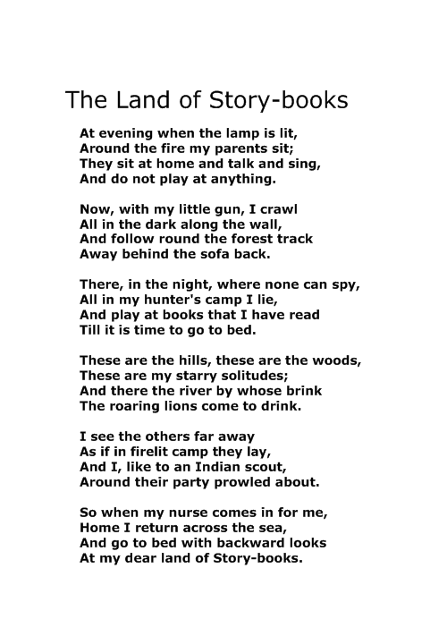

By Robert Louis Stevenson

**My Bed Is A Boat**

**By Robert Louis Stevenson**

**My bed is like a little boat;**

**Nurse helps me in when I embark;**

**She girds me in my sailor's coat**

**And starts me in the dark.**

**At night I go on board and say**

**Good-night to all my friends on shore;**

**I shut my eyes and sail away**

**And see and hear no more.**

**And sometimes things to bed I take,**

**As prudent sailors have to do;**

**Perhaps a slice of wedding-cake,**

**Perhaps a toy or two.**

**All night across the dark we steer;**

**But when the day returns at last,**

**Safe in my room beside the pier,**

**I find my vessel fast.**

**At the Sea-Side**

By Robert Louis Stevenson

When I was down beside the sea

A wooden spade they gave to me

To dig the sandy shore.

My holes were empty like a cup.

In every hole the sea came up

Till it could come no more.