Name___________________________________________
RL.2.9. I Can: Compare and contrast two or more versions of the same by different authors or from different cultures.
Book Title | Country of Origin | Characters | Ingredients | Setting | Moral
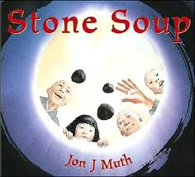
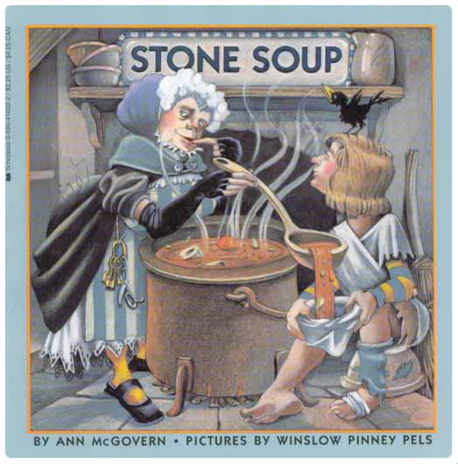
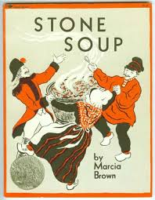
Book Title | Country of Origin | Characters | Ingredients | Setting | Moral
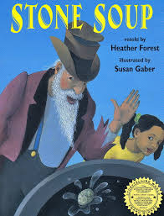
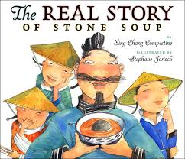
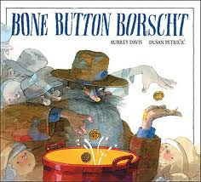

Now that you have gathered all of your information and heard six different versions of Stone Soup write an opinion piece on which version is the best. Be sure to include information from in sheet for your reasons and examples. Be sure to include the author’s name since there are so many versions.

