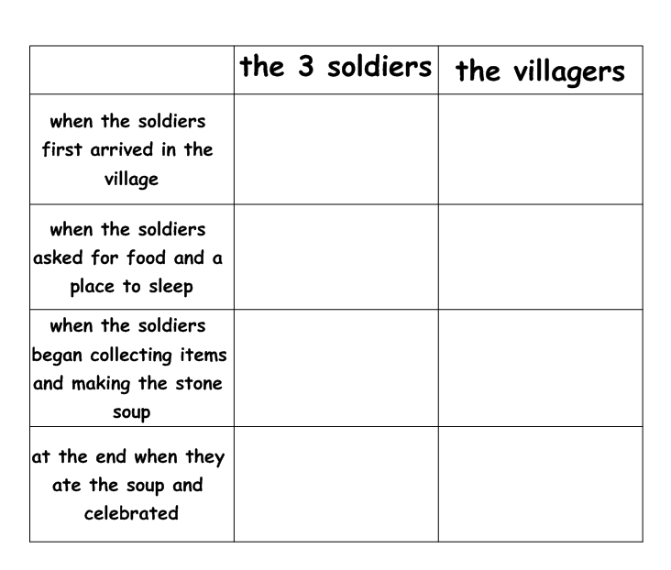

|  |  |  |  |
| --- | --- | --- | --- |
| The Pied Piper | The Mayor | The Townsfolk | The Children |
|  |  |  |  |