Stone Soup by Marcia Brown

Name________________________

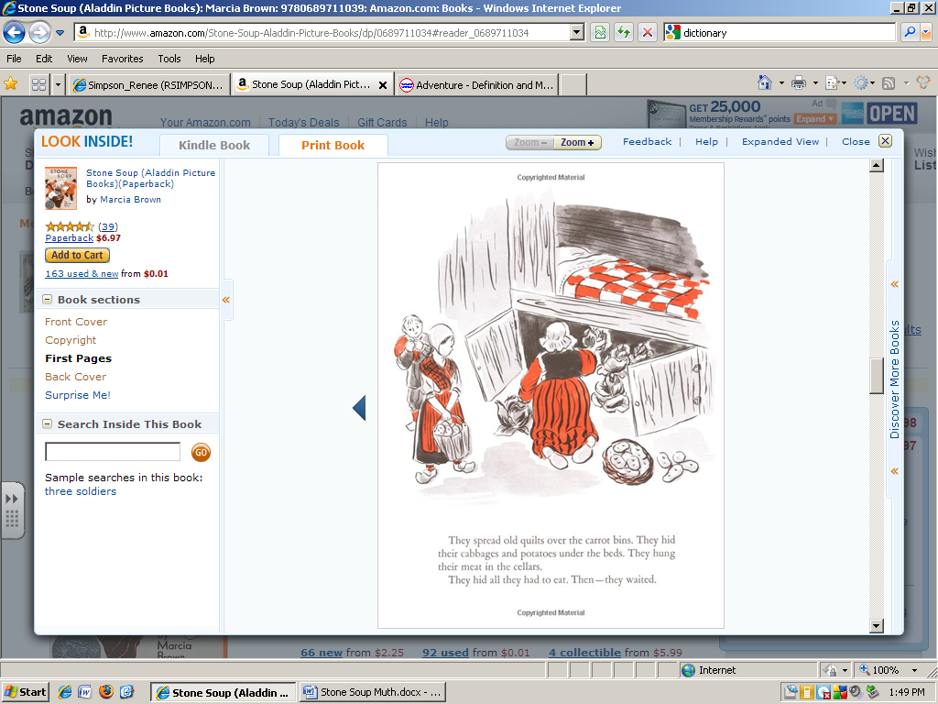

The woman is hiding the food __________ the bed.

inside beneath on top of yummy

The potatoes are in the ___________.

kitchen pan dirt pail

The family does not want to _______ their food.

keep cook share eat

Food is kept in a…

trunk bucket pantry party