Name: __________________________________________ Date: ________________
Compare these texts.
Comparing Stone Soup  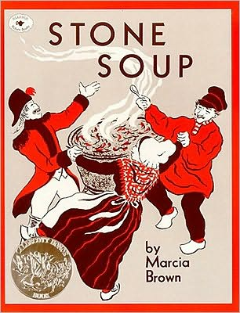 | 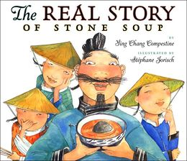 | 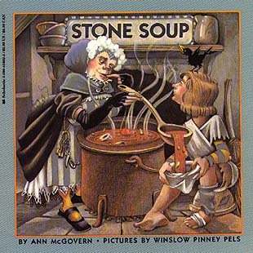 | 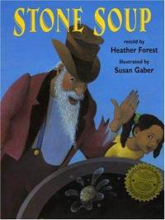 | 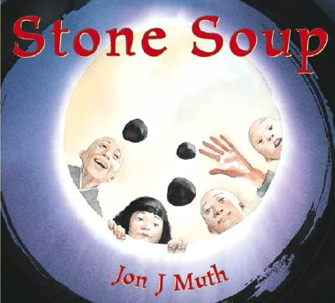
WHO are the characters?

WHEN AND WHERE is the setting?

WHERE is the story from?

WHAT was the moral?

