Day 1

The Character Transformation and the vocabulary were completed along with the read aloud.

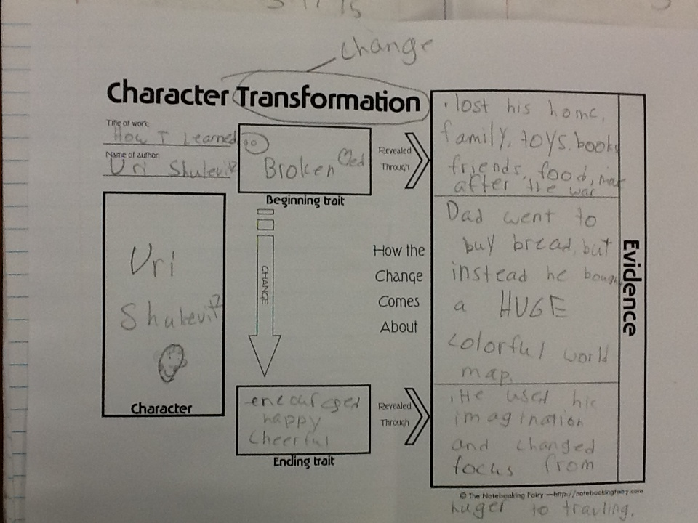

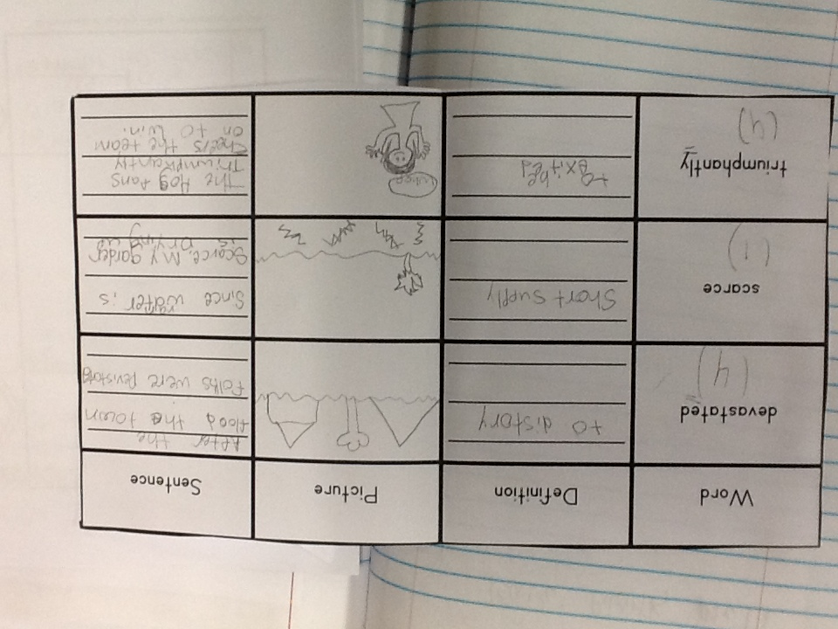

On the third day of this lesson, the students finally used the slides from the Power Point as a review of the locations. They used the slides as flip-ups and recorded the continent it would be found and if the locations were a state, country, or continent, because of the continued confusion of these terms.



