Fill in the circle that shows the best picture of the word.

Arrange
 |  | 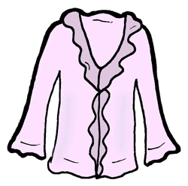

Beamed
 |  | 

Twisted
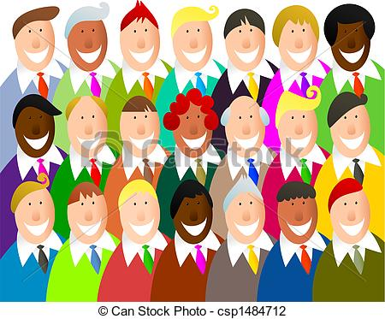 | 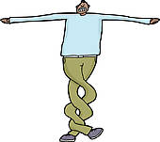 | 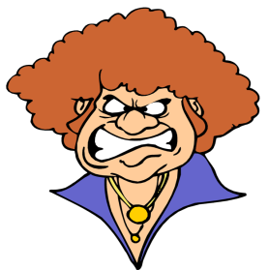

Blouse
 |  | 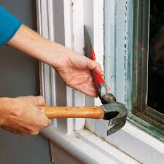

Skiff
 |  | 

Creep
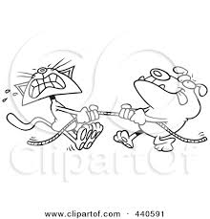

Scowling

Folks

Pried
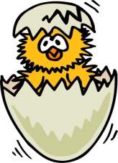

Heaves


Hurdle

Listen to these sentences as your teacher reads them aloud. Fill in the circle for the sentence with the bold word used correctly.

- I have always admired Harriet Beecher Stowe.
1.
- The admired paper should be thrown away.

- Put all of the books on the counter over yonder.
2.
- I like the yonder flower better.

- Your boycott needs more purple.
3.
- Should we boycott the diner for being mean to people who speak Spanish?

- I will not budge when you push me.
4.
- You should be budge when your friends are playing.

- Being nonviolent is an appropriate response to hatred.
5.
- It is so nonviolent for people to whisper.!

- There is an equality puppy running across the street.
6.
- Equality is important for how we treat people.

- Where did you buy your lulls?
7.
- When the mom sings, it lulls the baby to sleep.

- My mom’s house is a haven when I’m stressed.
8.
- Do you think people go to haven when they die?

- My opinion on recess wavered after hearing the PE teacher.
9.
- The boy wavered good bye when he left.

- The young lady gazes at her new diamond ring.
10.
- You’ll need your gazes if it’s raining outside.

- Teachers need to treat their students fairly.
11.
- The fairly jumps were hard on field day.

Read the sentences. Fill in the circle that best matches the meaning of the underlined word.

- Damion gathered his folders and put them in his backpack.

- Put together
- Checked
- Looked at

- Some people think McDonald’s is inferior to Sonic.

- Better
- Worse
- Close

- The boys were up to mischief when they snuck into school after dark.

- A surprise
- Looking
- No good

- Why isn’t running in the school allowed?

- Can’t do it
- Can do it
- Bad choice

- You can tell your woes to an adult you trust.

- Sad things
- Secrets
- Fears

- The girl refused the cute little puppy.

- Kicked
- Said no
- Held

- You need to stop fidgeting when we read.
- Moving around
- Arguing
- Daydreaming

- How do you persuade your parents to let you go to bed later?

- Listen to
- Talk to
- Convince

- She is committed to being a good friend.

- Stick to it
- Eating
- Nice

- How do you get motivated to finish your homework?

- Work hard
- Want to
- Quickly

- Do elephants irritate tigers?

- Make unhappy
- Step on
- Bigger than

Circle the words that are capitalized correctly.

Car Diego Friday School Minecraft Sonic Shoe

Circle the irregular past tense verbs.

walked ran jumped went told smiled slept

Circle the words with a prefix.

Preview Rewrite Record Butterfly Notebook Nonsense

How does a prefix change happy to unhappy?

Read the following sentences. Each sentence has a word missing. Fill in the circle to show which word best completes the sentence.

If you take a you can do something better.
- Chance
- Protest
- Spectacle

Don’t make a in the middle of an assembly.
- Chance
- Protest
- Spectacle

You can what you don’t like but it might not work.
- Chance
- Protest
- Spectacle

Cut and glue these events in chronological order

1. |  | Slavery and Underground Railroad
2. |  | Civil  Rights  Movement
3. |  | Integration
4. |  | Segregation
5. |  | Emancipation Proclamation

