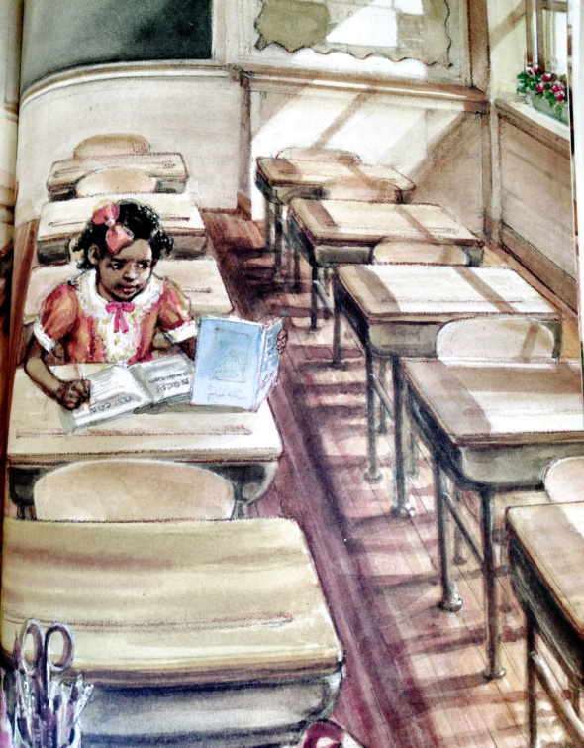

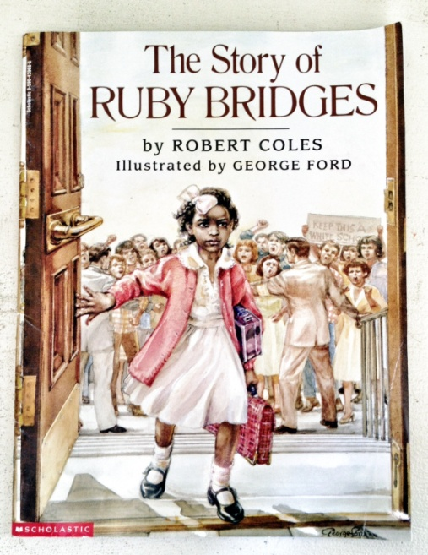

Frantz Public School

New Orleans, LA

1960

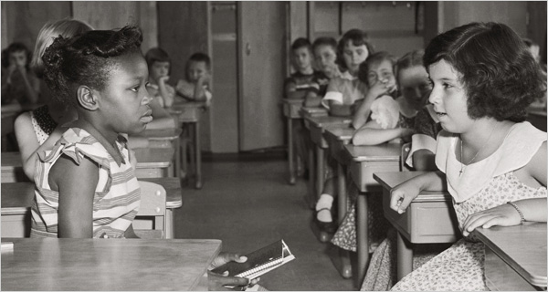

First day of desegregation, on Sept 8, 1954, at Fort Myer Elementary School in Fort Myer, VA.

<http://www.nytimes.com/2006/12/10/weekinreview/10liptak.html?_r=1&oref=slogin>

|  |  |  |
| --- | --- | --- |
| Features to Compare | Ruby Bridges, Civil RIghts for Kids, Children's Books, Robert Coles | http://graphics8.nytimes.com/images/2006/12/10/weekinreview/10liptak.600.jpg |
| Setting |  |  |
| Point of View |  |  |
| Feelings |  |  |

How are they alike?

How are they different?