from Henry’s Freedom Box

By Ellen Levine

Many weeks passed. One morning, Henry heard singing. A little bird flew out of a tree into the open sky. And Henry thought about being free.

But how? As he lifted the crate, he knew the answer.

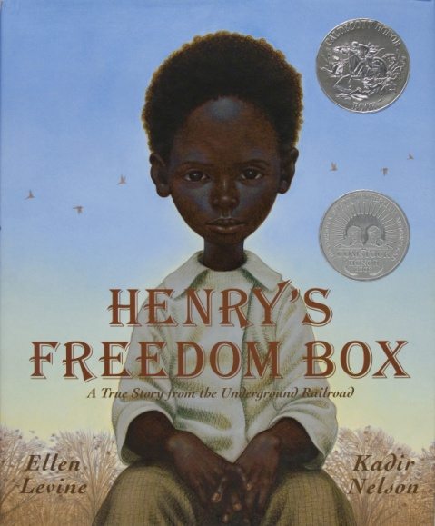 He asked James and Dr. Smith to help him. Dr. Smith was a white many though thought slavery was wrong. They met early the next day at an empty warehouse.

Henry arrived with a box.

“I will mail myself to a place where there are no slaves!” he said.

James stared at the box, then at Henry. What if you cough and someone hears you?”

“I will cover my mouth and hope,” Henry said.