Moses: When Harriet Tubman Led Her People to Freedom

Name________________________

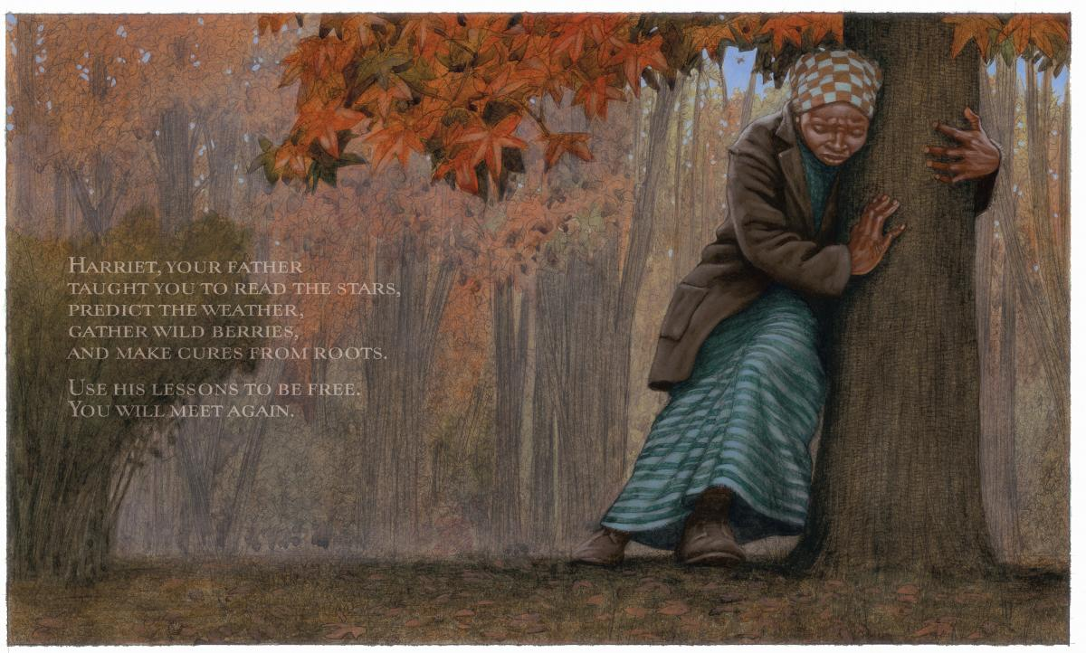

Harriet is ____________ on the tree.

climbing sitting leaning walking

She is feeling __________________.

happy angry funny tired

Running away from a slave owner was _________________.

foolish dangerous fun happy

To run away is to…

escape travel dream fly