Henry’s Freedom Box

Name__________________

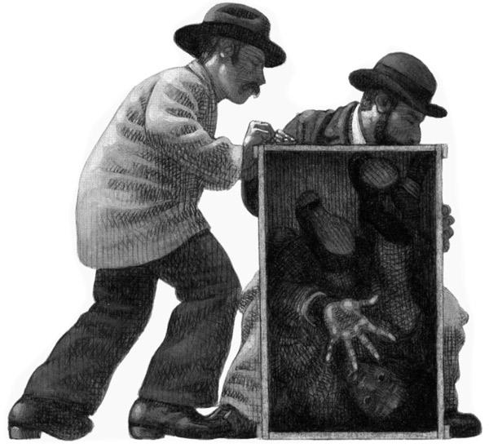

Henry is _______________ in the box.

sitting hiding pushing eating

The men are trying to _______________.

help Henry move the box go home sit down

The box probably ______________ the ground.

scraped helped moved bounced

Inside the box, Henry is ______________.

mad happy crowded funny