From Zen Shorts

By John J. Muth

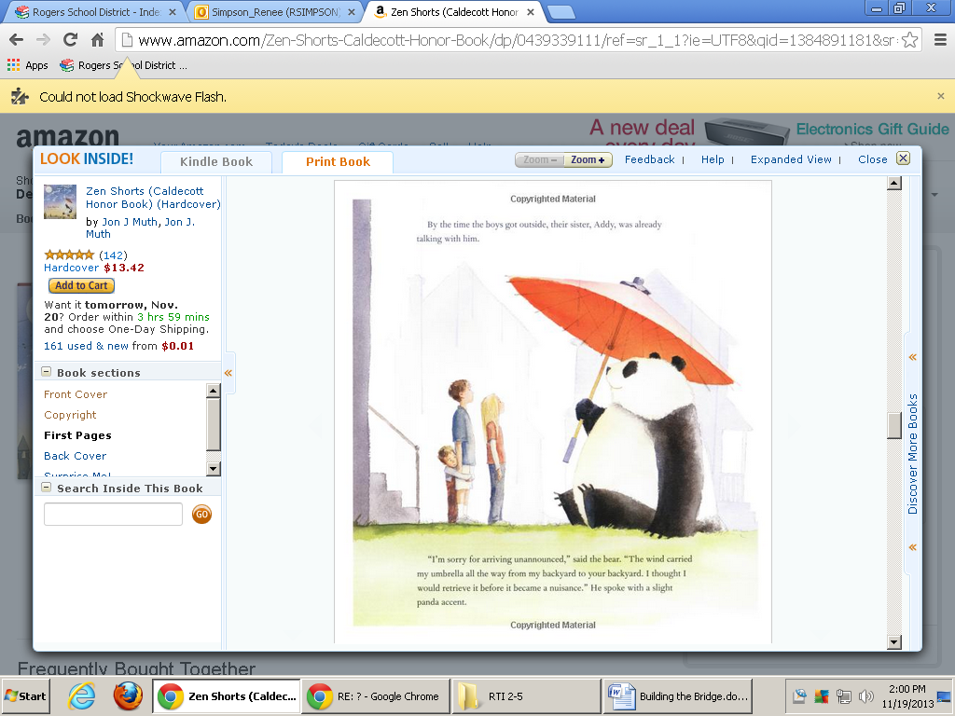By the time the boys got outside, their sister, Addy, was already talking with him.

“I’m sorry for arriving unannounced,” said the bear. “The wind carried my umbrella all the way from my backyard to your backyard. I thought I would retrieve it before it became nuisance.” He spoke with a slight panda accent.

Michael introduced himself. Then Addy introduced Karl because Karl was shy around bears he didn’t know. And this is how Addy, Michael, and Karl met Stillwater.

**1** What is this story mostly about?

Different kinds of bridges

Painting bridges

Making a famous bridge

**2** What is the Panda’s name?

Michael

Karl

Stillwater

**3** How did the Panda travel from his home to the children?

By car

By ocean liner

By umbrella

**4** Which word describes the panda?

experimental

considerate

funny

**5** To be considerate is to have…

good manners no home a car big feet

**6** To retrieve is to…

shower smell fetch ignore

**7** To become a nuisance is to…

juggle annoy grow up laugh

The robber thought my uncle was crazy. He took the robe, dashed out the door and escaped into the night.

All I had to give him was my tattered robe. if only I could have given him this wonderful moon.

The next morning the horse returned, brings with it two other wild horses.

Maybe good luck and bad luck is all mixed up. You never know what will happen next.