Second Grade RL.2.7

What do the standards say?

RL.7- Integration of Knowledge and Ideas

Integrate and evaluate content presented in diverse media and formats, including visually and quantitatively, as well as in words..

|  |  |
| --- | --- |
| **1** | Use illustrations and details in a story to describe its characters, setting, or events. |
| **2** | Use information gained from the illustrations and words in a print or digital text to demonstrate understanding of its characters, setting, or plot. |
| **3** | Explain how specific aspects of a text illustrations contribute to what is conveyed by the words in a story (e.g., create mood, emphasize aspects of a character or setting) |

**Part 1-**

I can use information gained from the words to help me understand a character’s personality.

<http://learnzillion.com/lessons/2110-understand-a-characters-personality-traits>

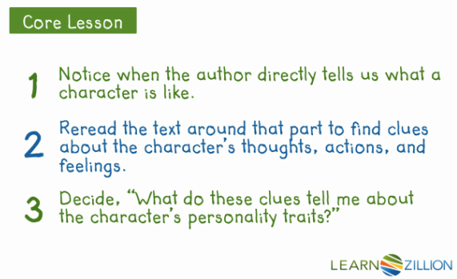

**Part 2-**

I can use information gained from the illustrations to help me understand a character’s personality.

<http://learnzillion.com/lessons/2092-use-information-from-illustrations-to-understand-characters>

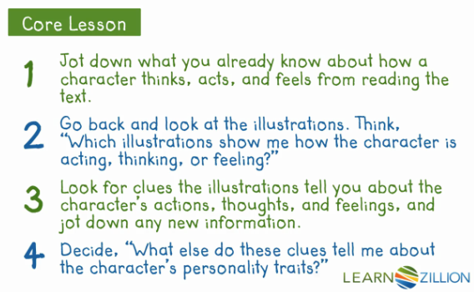

|  |  |  |
| --- | --- | --- |
| Character: | | |
| http://www.hostpapasupport.com/go/images/contest-logos/props/png/thought-bubble.pngThoughts | http://www.clker.com/cliparts/Z/e/p/U/7/c/action-hi.pngActions | http://www.clker.com/cliparts/R/R/M/t/1/p/dark-pink-heart-hi.pngFeelings |
|  |  |  |
|  |  |  |
|  |  |  |

What do these clues tell me about the character’s personality traits?