Second Grade RL.2.3

What do the standards say?

RL.3- Key Ideas and Details

Analyze how and why individuals, events, and ideas develop and interact over the course of a text.

|  |  |
| --- | --- |
| **1** | Describe characters, settings, and major events in a story, using key details. |
| **2** | Describe how characters in a story respond to major events and challenges. |
| **3** | Describe characters in a story (e.g., their traits, motivations, or feelings) and explain how their actions contribute to the sequence of events. |

<http://learnzillion.com/lessons/2183-describe-how-characters-respond-to-events-in-a-story>

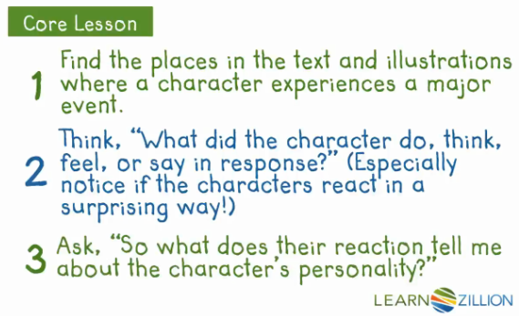

|  |  |  |  |
| --- | --- | --- | --- |
| Character: | | | |
| Major Event: | | | |
| Do | Think | Feel | Say |
|  |  |  |  |
|  |  |  |  |
|  |  |  |  |

What does the character’s reaction tell me about the characters personality?