Day 1:
RI.2.9
Compare and contrast the most important points presented by two texts on the same topic.
The outcome of the learning is for students to be able to see how 2 different informational texts give information, and how that information helps to give different knowledge (depending upon the source)
I suggest doing the first lesson as a whole group, filling in the chart together. I only took information from parts of both books. The purpose is not to read the books to their entirety, but to see how information is given between both books. The focus is finding out the kinds of bridges, not all the details about how they are built, etc. I would definitely show the differences between the two books (how they are laid out, how easy is it to find information, etc.)

Teacher Notes | Source A:  Bridges! By Carol Johmann  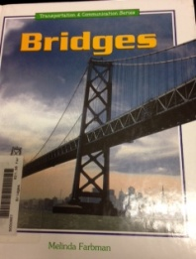  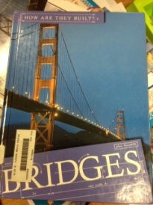  or | Source B:  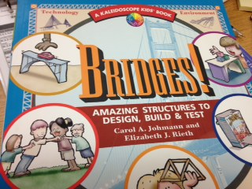  Bridges by Melinda Forman (chapter 2)
Kinds of Bridges  Arch  Beam  Suspension | Arch: Facts (p.23)  - Strongest  - Boats could pass through  - Parts of the arch are being squeezed together  - Romans first creators of it  Cofferdams are used to help support (p.29)  Beam Bridge: Facts (p. 37)  - Easier to build  - Less expensive  - Simple in design  - Some made with trestles (p.39)  Suspension: Facts (p.52)  - Look like thread is holding up the bridge  - Cable, wire, chain were all used to make bridges; steel is used today | Arch: Facts (p.13)  - Shaped like a half a circle  - It is strong  - The weight of cars falls downward  Beam Bridge: Facts (p.11 )  - Simplest  - Deck rests on two piers  - Some have trusses  - A draw bridge is a type of beam bridge  Suspension: Facts (p.13 & 14)  - Cables, ropes or chains are strung though tall towers.  - The deck of the bridge hands, or suspends from the cables.  - Usually have trusses  - Used when long distances must be crossed.
Text Features | Photographs, diagrams, labels, drawings, charts, | Photographs, labels, table of contents,
Think about the two different books we looked at today to get information about the kinds of bridges. Which book would you use to learn more about bridges? Why would you choose that book?
This chart looks at 2 different sources to find out information on the kinds of bridges. These books are very different from each other, but give some of the same information. They should be good to compare. We want for the students to learn as readers, that different books are going to give us different information, even when it is on the same topic.

Day 2:
RI.2.9
Compare and contrast the most important points presented by two texts on the same topic.

I chose to use a book and a video for resources. I thought it would be good for students to see that we can get great information from the History channel, but you have to listen to it a few times to get your information down because of its format!

Set the purpose of reading/watching the texts; we want to find out more information about the Brooklyn Bridge and both these books are about the Brooklyn Bridge. What questions do you think we will get answered about the bridge? What is this book mainly talking about?

Why was it built? When was it built? What kind of bridge is it? Are there interesting facts about the bridge?

Brooklyn Bridge(be careful with the advertisements before the video)
Teacher  Notes | Source A:  Building America, The Brooklyn Bridge  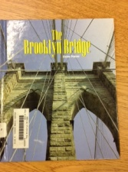  by, Elaine Pascoe | Source B:  Youtube from History Channel  http://www.history.com/topics/new-york-city/videos#deconstructing-history-brooklyn-bridge
When was it built? | Started in 1869 and completed in 1883
Why was it built? | (p.9)  There needed to be a way to get from Manhattan to New York City; farmers wanted to use the land in Manhattan | There were workers that needed to get to Manhattan Island
What kind of bridge is it? | (P.14)  Suspension bridge; because it had to go across the East River and be tall enough for ships to go under it. | World’s longest suspension bridge
Interesting Facts | - There are walkways on the bridge so that people can walk across it (p. 40)  - It is a National Historic Landmark  - The original engineer died and his son completed it (Roeblings, p. 17) | - $15 million to make –back then  - 20 workers died while making it  - 1st bridge to have electric lights.
Text Features | Photographs, bold print, diagrams, index, glossary, timeline | Video, music, diagram, facts
How these two resources on the Brooklyn are Bridge the same? How are they different?

Name:__________________________________ Date:___________________________________

 | Source A:  Building America, The Brooklyn Bridge  by, Elaine Pascoe | Source B:  Youtube from History Channel  http://www.history.com/topics/new-york-city/videos#deconstructing-history-brooklyn-bridge
When was it built?

Why was it built?

What kind of bridge is it?

Interesting Facts

Text Features

How these two resources on the Brooklyn are Bridge the same? How are they different?

I can compare and contrast important information about the Brooklyn Bridge from 2 different sources.

