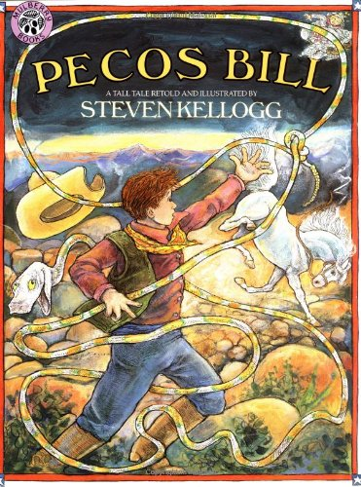
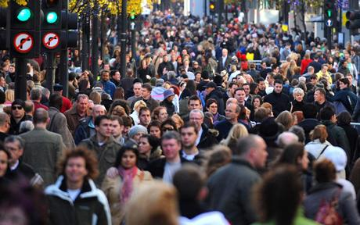
crowded
Too many people
close together in a place.


ambushed
Someone who hides and
then jumps out and attacks
someone else without them knowing.


sulking
Someone who is mad
or upset and won’t talk.
(pouting)

