Name___________________ RL 2.5, 2.7

The Tall Tale of Pecos Bill
Unit 2 Summative Assessment

Write what happened in the beginning, middle, and end of this story.

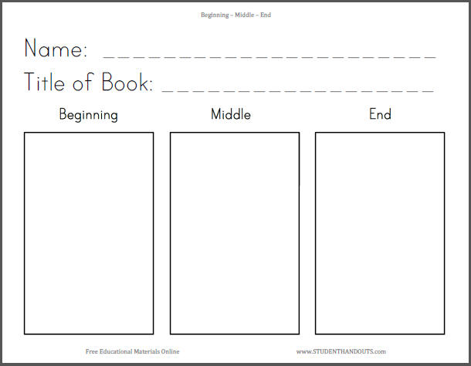

I know that the setting of the story is__________________________.

I know this because in the illustration I can see_____________________

_____________________________________________________.

Pecos Bill lived in “The Wild West”. We know from this passage that he was a “wild” character. Write two things from the text that show he was a “wild” character.

I know Pecos Bill was “wild” because:
- _______________________________________________

- _______________________________________________

