Title | 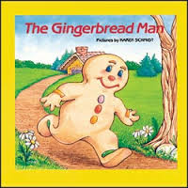 | 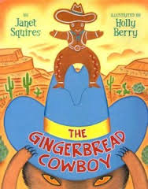
Setting
Where?
When?
Characters
Who?
Problem
What?
Solution
How?
Lesson
Why?

