The Tortoise and the Jackrabbit

Name________________________

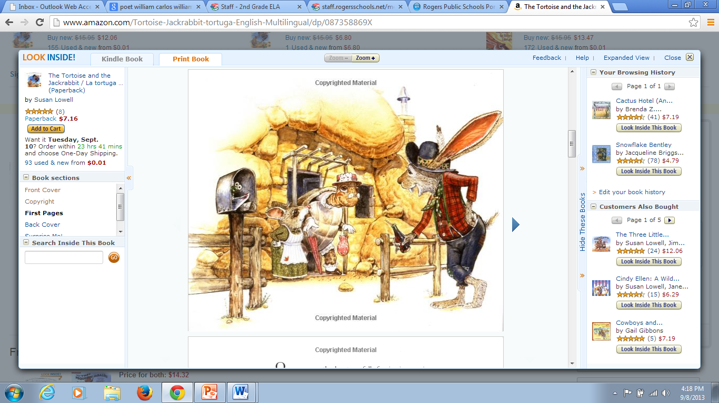

Jackrabbit is ___________ on the fence.

standing jumping walking leaning

Tortoise and Mouse are _________ the house.

eating exiting emptying elephant

Jackrabbit’s ears are not ___________.

long happy short big

To be old is to be…

friendly silly elderly young