R is for Rodeo

Adapted from B is for Buckaroo: A Cowboy Alphabet

By Louise Doak Whitney & Gleaves Whitney

Rodeos began in 1888 when cowboys gathered after the day’s work to show off their roping and riding skills. Today many towns have rodeo. People get excited to see what the cowboys can do.

Every official rodeo includes five standard events: bull riding, saddle bronc riding, calf roping, bulldogging, and bareback riding. Barrel racing is the only women’s event and is sometimes included in the rodeo.

One of the best parts of the rodeo is watching the rodeo clowns. Rodeo Clowns are very good horse riders. Their job is to help protect cowboys if they fall off a bull or bronco.

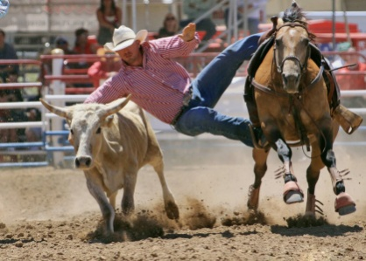

1 What is the rodeo clown’s job?

Make people laugh.

Protect the Cowboys.

Fall off the bulls.

2 Why do people get excited to see a rodeo?

The rodeo is exciting.

Horses are pretty.

Every rodeo has five events.

3 Which is the only women’s event?

Bull Riding

Calf Roping

Barrel Racing

4 What is this story mostly about?

Bronc riding and roping

Rodeos are fun

What happens at a Rodeo