 | Lesson Structure |  | Classroom Instruction that Works  Chapter | Lesson  RI.2.8 Describe how reasons support specific points the author makes in a text.
G | Goal  Curriculum Standards  Benchmarks  Objectives | Stated at the beginning of a lesson and unit, clear targets let students know the direction of the learning and they can begin to track their own progress. Feedback toward this goal helps the student to understand learned progress throughout the instruction. | (8) Setting )Objectives and Providing Feedback  (4) Reinforcing effort and Providing Recognition | I can describe how reasons support specific points in a text.
A | Access Prior Knowledge | Accessing prior knowledge allows students the neural courtesy to reach into their own memories for information in order to prepare to connect to new ideas and procedures. | (6) Nonlinguistic Representations  (7) Cooperative Learning  (10) Cues, Questions and Advance Organizers | Show SMART slide with Goldilocks falling off Baby Bear’s chair.  Who is this? What happened to her? Has this ever happened to you?
N | New Information | Presentation of new information (declarative and procedural) through reading, lectures, video, or discussion with strategies that help the learner gather and organize the information such as note taking, graphic organizers, questioning, and practice. | (3) Summarizing and Note Taking  (5) Homework and Practice  (11) Teaching Specific Types of Knowledge | The chair broke when Goldilocks sat on it because she was too big…the chair was not strong enough to hold her.  When an author writes an informational book, they must make sure they have enough information to support what they say.  Take a look at the cover of this book…let’s read it’s title together. (You Wouldn’t Want to Live in a Wild West Town.) Do you agree or disagree with this statement. Turn and talk to your neighbor about it. Share  The point the author is trying to make is that you wouldn’t want to live in a Wild West town. We’re going to take a look at the introduction for this book. It’s just one page from the book, but we should be able to see if the author has evidence strong enough to keep the chair from falling down. Let’s see what we can find.  Give students time to read and discuss page from text. (handout) Discuss possible evidence in the text.  Slide 7-Let’s take a look at what we found…  Does the author tell us why we wouldn’t want to live there? Does he provide enough evidence to support the statement? If we were to sit in this chair, would the chair fall down?
A | Application | Students use thinking skills with declarative knowledge to construct new ideas and practice to automaticity and strategic use for procedural knowledge. | (2) Identifying Similarities and Differences  (9) Generating and Testing Hypotheses  (10) Cues, Questions and Advance Organizers | What support could we give to this statement…  You wouldn’t want to play outside during a storm.
G | Generalize | Generalizing completes the cycle of the lesson bringing the learner back to the goal. Using strategies such as nonlinguistic representations, generating questions or self-evaluating allows students to put "the tab on the folder" in order to retain information for longer periods of time. | (8) Setting )Objectives and Providing Feedback  (4) Reinforcing effort and Providing Recognition | I can describe how reasons support specific points in a text.
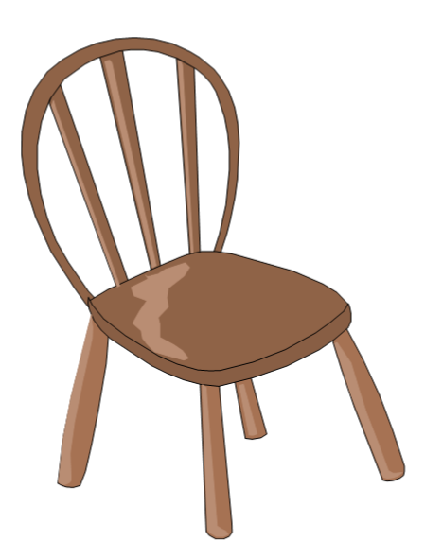
We have learned new things in Kindergarten

