C is for Chuck Wagon

Adapted from B is for Buckaroo: A Cowboy Alphabet

By Louise Doak Whitney & Gleaves Whitney

The chuck wagon was named after its founder, Charles (Chuck) Goodnight, a Texas cattle rancher. Goodnight knew that cowboys on long trail rides like to eat tasty vittles (food). The chuck wagon was where the cook prepared meals. The cook was often called a Cookie. Cookies usually made thick soups, baked beans, and biscuits. The cowboys treated Cookie with great respect. If they didn’t, Cookie might “accidentally” burn the beans or biscuits!

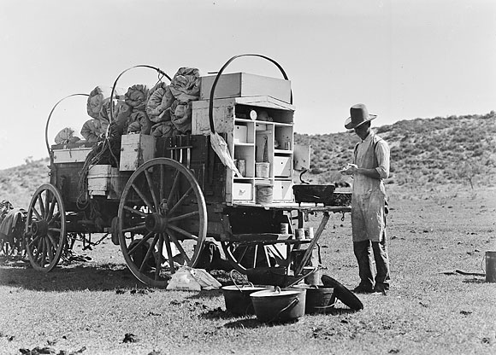 Jerky is a popular snack for cowboys. Jerky is thin strips of meat that are dried and salted. Because it is not heavy and does not spoil quickly, cowboys like to keep it in their packs to nibble on.

1 Who invented the Chuck Wagon?

Cookies

Cowboys and Jerky

Charles Goodnight

2 What did Cookies make on the chuck wagon?

Beans and biscuits

Dried and salted

Pizza

3 Which is a reason the Cookie might burn the food?

Cowboys made fun of him

Horses pulled the wagon

Jerky is salted

4 What is this story mainly about?

Food in Cowboy Days

Thin strips of meat

Biscuits and Beans