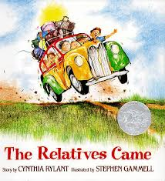 | RL2.1  Who: relatives  When: (infer) “…when their grapes were nearly purple enough to pick, but not quite.” (last page) “… next summer.”  Where: a day and night’s drive from Virginia  What: spending several weeks with the relatives, helping, eating, visiting, time together
RL.2.4
(alliteration)
…purple enough to pick…
…back into our beds that felt too big…
… into their soft and silent beds and dreamed about next summer…
(descriptive language)
… a station wagon that smelled like a real car…
… almost purple grapes…
…their wrinkled Virginia clothes…
RL.2.5
(introduces) the relatives are coming from Virginia, driving day and night, when the grapes are not quite right, in an old station wagon- beginning tells who, infers when, gives an idea about where
W.2.3 This text could be a model for any of the following components of narrative writing.
- Well elaborated event or sequence of events
- Temporal words: So…Then… And finally… Finally… And when they were finally home…
- Sense of closure: circular- ends like it begins
- Details: You’d have to go through at least four different hugs to get from the kitchen to the front room/some with an arm across one person and a leg across another/crawled back into our beds that felt too big, too quiet

Second Grade- Unit 1 Teaching with The Relatives Came by Cynthia Rylant

