***Peepers*** *by Eve Bunting*

**Reread the introduction to the story.**

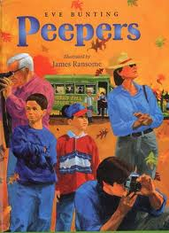

In the fall my dad opens up the shed where our little green bus sits waiting. Jim and I help him take off the blankets we piled on it last winter. The bus says FRED’S FALL COLOR TOURS on the side.

“Sparkle it up, boys,” Dad orders. “The Leaf Peepers are coming.”

**Explain how the author introduces the story.**

_______________________________________________________________________________________________________________________________________

Name __________________