**Poppleton in Spring**

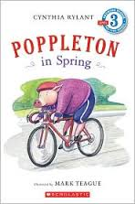

Who?

Where?

When?

What?

**Adventures with**

**Poppleton**

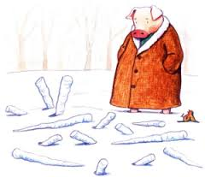

**Name _________________**

**Poppleton Everyday**

Who?

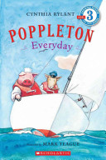

Where?

When?

What?

**Poppleton in Winter**

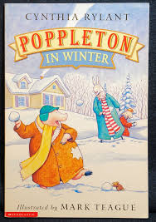

Who?

Where?

When?

What?

**Henry and Mudge**

**______________________________**

Who?

What?

When?

Where?