**Adventures with**

**Henry and Mudge**

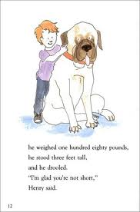

**Name _________________**

**Henry and Mudge and the Snowman Plan**

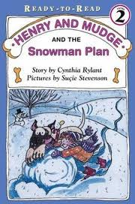

Who?

Where?

When?

What?

**Henry and Mudge**

**The First Book**

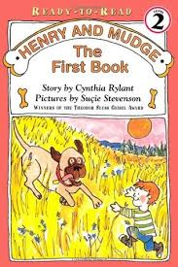

Who?

Where?

When?

What?

**Henry and Mudge**

**and the Wild Wind**

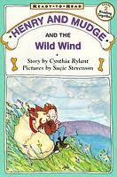

Who?

Where?

When?

What?

**Henry and Mudge**

**and the Starry Night**

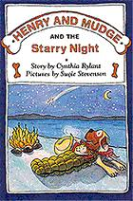

Who?

Where?

When?

What?

**Henry and Mudge**

**______________________________**

Who?

What?

When?

Where?