Snowflake Bentley

Name________________________

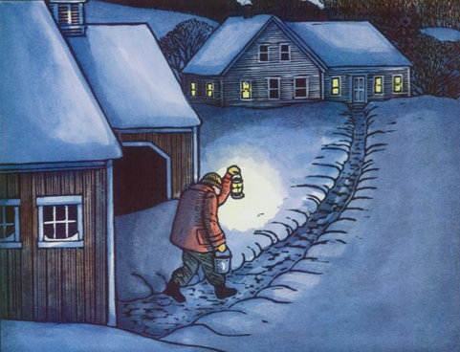

The setting of this story is______________.

daytime long ago a dream in the city

The boy is on a ____________.

mission lake street path

His _____________ will keep him warm.

necktie blanket overcoat fireplace

Bentley uses a __________ to see where he is going.

lantern flashlight torch light bulb