**The Kittens**

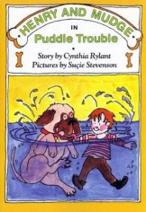

Who?

Where?

When?

What?

**Adventures with**

**Henry and Mudge**

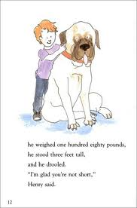

**Name _________________**

**The Snow Glory**



Who?

Where?

When?

What?

**Puddle Trouble**



Who?

Where?

When?

What?