**Above Their Heads**

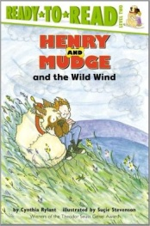

Who?

Where?

When?

What?

**Some Wind**



Who?

Where?

When?

What?

**Pows and Booms**



Who?

Where?

When?

What?

**The Enemy Couch**



Who?

Where?

When?

What?