**Thanksgiving Guest**

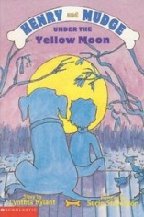

Who?

Where?

When?

What?

**Adventures with**

**Henry and Mudge**

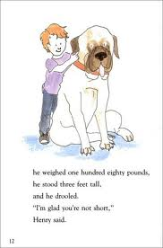

**Name _________________**

**Together in the Fall**



Who?

Where?

When?

What?

**Under the Yellow Moon**



Who?

Where?

When?

What?

**Henry and Mudge**