**Snow Aliens**

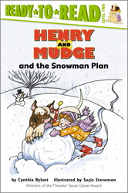

Who?

Where?

When?

What?

**Adventures with**

**Henry and Mudge**

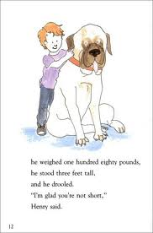

**Name _________________**

**Contest!**



Who?

Where?

When?

What?

**At the Park**



Who?

Where?

When?

What?

**Henry and Mudge**